UAB Office of the Provost Organizational Chart
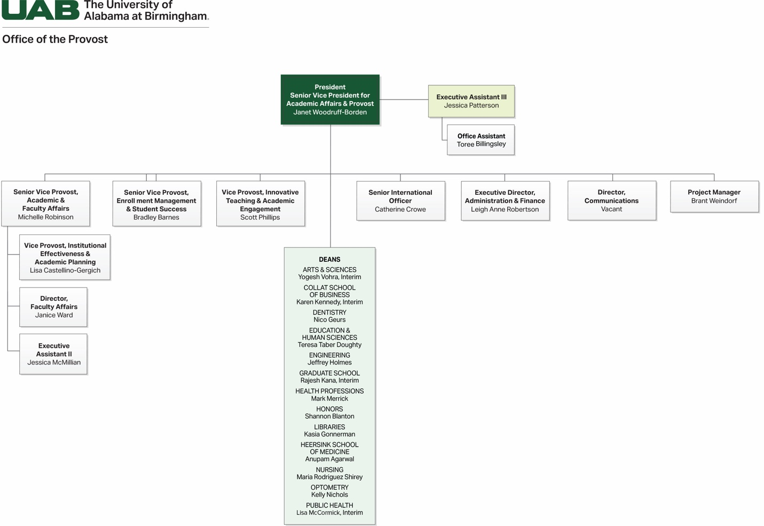

President, Senior Vice President for Academic Affairs & Provost, Janet Woodruff-Borden*
- Executive Assistant Ill, Jessica Patterson*
  - Office Assistant, Toree Billingsley

Senior Vice Provost, Academic & Faculty Affairs, Michelle Robinson
- Vice Provost, Institutional Effectiveness & Academic Planning, Lisa Castellino-Gergich
- Director, Faculty Affairs, Janice Ward
- Executive
- Assistant II
- Jessica McMillian

Senior Vice Provost, Enrollment Management & Student Success, Bradley Barnes

Vice Provost, Innovative Teaching & Academic Engagement, Scott Phillips

Senior International Officer, Catherine Crowe

Executive Director, Administration & Finance, Leigh Anne Robertson

Director, Communications, Vacant

Project Manager, Brant Weindorf

Deans*
- Arts & Sciences, Yogesh Vohra, Interim
- Collat School of Business, Karen Kennedy, Interim
- Dentistry, Nico Geurs
- Education & Human Sciences, Teresa Taber Doughty
- Graduate School, Rajesh Kana, Interim
- Health Professions, Mark Merrick
- Honors, Shannon Blanton
- Libraries, Kasia Gonnerman
- Heersink School of Medicine, Anupam Agarwal
- Nursing, Maria Rodriguez Shirey
- Optometry, Kelly Nichols
- Public Health, Lisa McCormick, Interim
*Denotes Leadership and Deans

