**Embolization of the Splenic Artery in Trauma (ELSA) – 2**

**Manual of Operations**

**April 2022**

**Table of Contents**

**Section 1: Overview……………………………………………………………………………………….3**

**Section 2: Patient recruitment and informed consent…………………………………..12**

**Section 3: Logging in to REDCap……………………………………………………………………24**

**Section 4: Screening……………………………………………………………………………………..25**

**Section 5: Randomization……………………………………………………………………………..27**

**Section 6: Demographic information…………………………………………………………….29**

**Section 7: Pre-hospital care and hospital arrival……………………………………………31**

**Section 8: Admission blood work………………………………………………………………….35**

**Section 9: Initial CT report…………………………………………………………………………….37**

**Section 10: Study intervention……………………………………………………………………..38**

**Section 11: Post-procedure care……………………………………………………………………53**

**Section 12: Safety monitoring……………………………………………………………………….59**

**Section 1 – Overview**

* 1. **Contact information**

**Andrew J. Gunn, MD (Study PI)**

Director, Interventional Oncology

Associate Professor, Division of Interventional Radiology

University of Alabama at Birmingham

Phone: 205-975-4850

agunn@uabmc.edu

**Jan O. Jansen, MBBS, PhD (Study PI)**

Associate Vice Chair for Clinical Trials

Director, Center for Injury Science

Professor, Department of Surgery

University of Alabama at Birmingham

Phone: 205-996-4700

jjansen@uabmc.edu

**April Riddle (Research Manager, UAB)**

Phone: 205-934-6499

ariddle@uabmc.edu

**Evan Hudson (Site Coordinator, UAB)**

Phone: 205-934-6499

evanhudson@uabmc.edu

**Study email:** elsa2@uabmc.edu

* 1. **Protocol Synopsis**

**Title:** Embolization of the Splenic Artery in Trauma II

**Acronym:** ELSA 2

**Study sites:** Five Level I trauma centers

**Study period:** Two years, with expected start in Spring 2022

**Study population:** Patients *≥*15 years of age with trauma resulting in grade III or higher splenic injury on contrast-enhanced CT as defined by the AAST guidelines who are clinically-eligible for proximal splenic artery embolization as an adjunct to non-operative management

**Objective:** To conduct a multi-center, Bayesian, randomized clinical trial evaluating the primary technical success, defined as the ability to deploy the assigned embolic and achieve stasis in the mid-splenic artery within 15 minutes, of coils and vascular plugs for proximal splenic artery embolization in the setting of high-grade splenic trauma. Ancillary endpoints will include technical aspects of the procedure and clinical outcomes.

**Primary outcome and hypothesis:** The primary outcome of the study is primary technical success of the procedure, defined as the ability to deploy the assigned embolic and achieve stasis in the mid-splenic artery within 15 minutes of deployment. We hypothesize the coils will have a higher primary technical success than vascular plugs.

**Ancillary outcomes and hypotheses:** Secondary outcomes will include: technical aspects of the embolization procedure, time to stasis in the mid-splenic artery, secondary technical success, procedural complications, post-procedural complications, splenectomy rates, length of hospital stay, transfusion requirements, and mortality. We hypothesize that there will be no difference between the groups in ancillary outcomes.

**Background:** Splenic injuries are common. Hemodynamically unstable patients with splenic injuries usually require immediate splenectomy. The management of hemodynamically stable patients with injuries to the spleen is less well-defined, and recognition of the key role of the organ in producing antibodies, monocytes, and activated lymphocytes has led to a shift in the management of splenic injuries towards preservation when possible.

Splenic preservation rates for patients with high-grade splenic injuries are improved when non-operative management (NOM) is supplemented by image-guided, trans-catheter splenic artery embolization (SAE). SAE is currently the standard of care for hemodynamically stable patients with high-grade splenic injuries. SAE is primarily performed using proximal splenic artery embolization (pSAE), and pSAE is most often accomplished using either coils or vascular plugs as the embolic agent. Both devices are FDA-approved for this indication.

The selection of embolic agents for pSAE is mostly based on operator experience and preference; although, patient-specific factors such as vessel diameter and tortuosity play a role. The only study to compare the efficacy of these two devices for pSAE is our single-center pilot/feasibility trial, “Embolization of the Splenic Artery after Trauma” (ELSA).

ELSA attempted to randomize 50 patients with splenic injuries to embolization with either coils or plugs. We demonstrated the feasibility of conducting such a study, in terms of enrolment (46/50, or 92%, of eligible patients were enrolled), adherence to treatment allocation, and collection of outcome data (complete data were obtained on all enrolled patients). We demonstrated that coils were associated with a higher posterior probability of primary technical success, but as the posterior probability was <95%, we did not regard the finding as convincing. As a pilot study with feasibility as a primary outcome, ELSA was not powered to detect a difference. We will therefore now conduct a multi-center follow up clinical trial, with the aim of evaluating the primary technical success of the two devices.

**Study design:** Multi-center, randomized trial with two groups. Equal random allocation to treatment will occur using stratified, permuted blocks with randomly chosen block sizes and stratification by site.

**Inclusion criteria:** *≥*15 years of age; trauma resulting in grade III or higher splenic injury on contrast-enhanced CT; splenic injury to be treated by non-operative management as decided by attending trauma surgeon and interventional radiologist; the attending interventional radiologist determines that the patient will undergo proximal splenic artery embolization with the specific method to be decided by randomization.

**Exclusion criteria:** Inability to obtain informed consent; ≤ 50kg; uncorrectable coagulopathy; patient is immunocompromised; pregnant; breast-feeding; non-English speakers; prisoners

**Study intervention and duration:** Eligible patients will be referred for proximal splenic artery embolization and randomized to coils or vascular plugs. Subjects will be followed for 30 days after the embolization procedure.

**Primary outcome measure:** Primary technical success - ability to deploy the assigned embolic and achieve stasis in the mid-splenic artery within 15 minutes of deployment

**Sample size:** 250 patients. Based on the results of our pilot/feasibility study, we anticipate that a trial with 250 patients will have 86% probability of success where success means a >90% posterior probability that coils are superior to plugs for primary technical success, assuming that the rate of primary technical success, as in the pilot was 88% for plugs vs. 96% for coils. If the true rates are 85% vs. 95% then we will have >90% chance of success. We aim to recruit 250 patients across five sites, over a period of 24 months.

**Analysis:** The primary analysis will be to estimate a posterior probability distribution for the difference in primary technical success rates between plugs and coils. This analysis will use a non-informative prior distribution. As a decision criterion, the trial will be considered a ‘success’ if there is ≥90% posterior probability that the success rate for coils is higher than from plugs. In keeping with the Bayesian design, we will report the estimated difference along with 90%, 95%, and 99% posterior highest density credible intervals to provide greater information for clinical decision making. A secondary analysis will consider including the data from the pilot in the form of a prior distribution, recalculating the posterior credible intervals accordingly.

**Safety monitoring:** All members of the patient management teams will be instructed as to the possible adverse events prior to the start of the trial. Details of safety monitoring and reporting procedures are found in Section 12. In short, site Primary Investigators are responsible for collecting and reporting adverse events from members of the patient management and study team at their site in accordance with the procedures detailed in this manual. The site Primary Investigator will record all adverse events. Non-serious adverse events need to be logged on the CRF, and the study team at the Center for Injury Science needs to be notified by sending a copy of the completed CRF to ELSA2@uabmc.edu within 10 working days. The site Primary Investigator will also need to report the event to the site IRB within 10 working days. Anticipated serious adverse events and unanticipated serious adverse events will be reported by the site Primary Investigator to the site IRB, and will be emailed to the ELSA trial office within 72 hours. These will be forwarded to the independent medical monitor. An independent medical monitor will review all adverse events and provide an unbiased written report of the events. The medical monitor must comment on the outcomes of the event or problem and in case of a serious adverse event, comment on the relationship to participation in the trial. If deemed necessary by the independent medical monitor, all sites will be notified by the trial office.

* 1. **Summary of Data Collected**

|  |  |  |  |  |
| --- | --- | --- | --- | --- |
| **ASSESSMENT** | **PRE-PROCEDURE** | **EMBOLIZATION** | **POST-PROCEDURE** | **30 DAYS** |
| Eligibility | X |  |  |  |
| Demographics | X |  |  |  |
| Source | X |  |  |  |
| Mechanism of Injury | X |  |  |  |
| Vital signs | X |  |  |  |
| Glasgow Coma Score | X |  |  |  |
| Vasopressor use | X |  |  |  |
| Intubated | X |  |  |  |
| Massive transfusion protocol | X |  |  |  |
| Injury Severity Score | X |  |  |  |
| Anti-coagulation or anti-platelet use | X |  |  |  |
| Laboratory work | X |  |  |  |
| CT findings | X |  |  |  |
| Procedure duration |  | X |  |  |
| Radiation dose |  | X |  |  |
| Contrast used |  | X |  |  |
| Angiographic findings |  | X |  |  |
| Type/size of embolics |  | X |  |  |
| Primary technical success |  | X |  |  |
| Secondary technical success |  | X |  |  |
| Procedural complications |  | X |  |  |
| Post-procedural complications |  |  | X | X |
| Transfusion requirements | X |  | X | X |
| Splenectomy |  |  | X | X |
| Mortality |  |  | X | X |

* 1. **Site Certification**

The purpose of the initial site visit is to review with the site Investigators and staff the final protocol, review regulatory requirements, and instruct study personnel in study procedures. Site visits may be completed virtually.

The study Principal Investigators (PI) and personnel from the Center for Injury Science (CIS) at the University of Alabama at Birmingham (UAB) are responsible for discussing in detail the type of patient to be recruited, the completion of the electronic case report forms (eCRFs), administrative procedures to be followed, and the current protocol/study procedures. They are also responsible for evaluating the site Investigators’ and coordinators’ understanding of the protocol and his/her obligations during the study, as well as, touring the facilities and confirming that all study-related clinical procedures can be completed. The site PI is responsible for ensuring that his/her study team staff participates in the site visit once the scheduled date, time and location are agreed upon. For study team staff that cannot participate in site initiation, the site PI shall ensure that staff receives the relevant training prior to working on the study.

Preparation for the site initiation visit:

* Personnel from the CIS will coordinate with personnel from the clinical site to schedule a date and time
* Personnel from the CIS will determine which regulatory documents are outstanding and need to be requested prior to or retrieved at the site visit
* Personnel from the CIS will send a confirmation letter outlining the purpose of the visit, including demonstration of a mock randomization, and any other items for discussion
* Personnel from the CIS will prepare a site certification checklist to be completed before site initiation. (Section 1.4.1)

During the site initiation visit:

* The protocol presentation will be presented.
* Attendance will be documented on the site visit log
* Obtain any missing regulatory documents not received prior to the visit.
* Discuss Federal requirements specified in FDA Form 1572 and IRB/REB requirements, including but not limited to:
  + Obtaining and documenting informed consent
  + IRB/REB approval and progress reports, including amendments and serious adverse events (SAEs)
  + Protocol Adherence
  + Maintenance of adequate and accurate case histories
  + Record retention
  + Site personnel responsibility log – to document who will be responsible for specific study functions, the Delegation of Responsibilities/Authority form must be completed and signed by the site PI.
* Check that the facility and resources are available to meet protocol requirements
* Ensure that the site PI and study personnel understand:
  + 24/7 staffing requirements for the study
  + Frequency of monitoring of subjects
  + Importance of obtaining primary endpoint data
  + Review of site certification checklist (Section 1.4.1) in accordance with the Site Personnel Responsibility Log.

Follow-up to the Site Initiation Visit:

* Personnel from the CIS will complete and send a follow-up letter to the site PIs, which outlines what was accomplished during the meeting and note any items that need additional attention. Copies of the report and follow-up letter are placed in the study file.
  + 1. **Site Certification Checklist**

**STUDY INITIATION CHECKLIST**

|  |  |
| --- | --- |
| STUDY TITLE | Embolization of the Splenic Artery after Trauma (ELSA 2) |
| PROTOCOL NUMBER | Pro00059398 |
| SITE, SITE NUMBER |  |
| SPONSOR NAME | The University of Alabama at Birmingham |
| PRINCIPAL INVESTIGATOR NAME |  |
| MONITOR NAME |  |
| DATE |  |
| METHOD OF VISIT | On-Site  Teleconference  Other, specify: |

List personnel in attendance from site, below. Attach attendance sheet.

|  |  |
| --- | --- |
| NAME, TITLE | ROLE |
|  |  |
|  |  |
|  |  |
|  |  |
|  |  |
|  |  |
|  |  |
|  |  |
|  |  |
|  |  |

Verify each document or activity required below. Attach any supporting documentation.

| NO. | DOCUMENT OR ACTIVITY (DISCUSSED/VERIFIED) | YES | NO | N/A | COMMENTS |
| --- | --- | --- | --- | --- | --- |
| 1 | Staff CVs signed/dated |  |  |  |  |
| 2 | Staff trained on protocol |  |  |  |  |
| 3 | Check required number of forms delivered to site (i.e. consent forms, case forms). |  |  |  |  |
| 4 | Sponsor and site have agreed to study contract and budget. |  |  |  |  |
| 5 | EC/IRB approval granted for study. |  |  |  |  |
| 6 | Staffing allocation complete. |  |  |  |  |
| 7 | Specific staff responsibilities discussed with staff |  |  |  |  |
| 8 | Staff trained in GCP. |  |  |  |  |
| 9 | Required facilities are available/functional. |  |  |  |  |
| 10 | Materials/equipment for study available/received. |  |  |  |  |
| 11 | Investigator’s file prepared |  |  |  |  |
| 12 | Final contract and budget signed and filed. |  |  |  |  |
| 13 | e-case forms available (if applicable) |  |  |  |  |
| 14 | Other supplies received (if applicable) |  |  |  |  |

|  |  |  |
| --- | --- | --- |
|  | | |
| *Name of Monitor (Print)* | | |
|  |  |
| *Monitor Signature* | *Date* |

|  |  |  |
| --- | --- | --- |
|  | | |
| *Name of Principal Investigator (Print)* | | |
|  |  |
| *Principal Investigator Signature* | *Date* |

* 1. **Study Flowchart**



**Section 2 – Recruitment and Informed Consent**

**2.1 Patient Population**

Inclusion criteria:

1. *≥*15 years of age
2. Trauma resulting in grade III or higher splenic injury on contrast-enhanced CT
3. Splenic injury to be treated by non-operative management as decided by attending trauma surgeon and interventional radiologist
4. The attending interventional radiologist determines that the patient will undergo proximal splenic artery embolization with the specific method to be decided by randomization.

Exclusion criteria:

1. Inability to obtain informed consent from patient or legally-authorized representative
2. ≤ 50kg
3. Uncorrectable coagulopathy
4. Patient is immunocompromised
5. Pregnant
6. Breast-feeding
7. Non-English speakers
8. Prisoners

**2.2 Informed Consent Development and Management**

The purpose of this section is to outline the procedures involved in development of the informed consent form templates and the subsequent review, tracking, and management of site specific IRB-approved consent forms

*Responsibilities of personnel from UAB* *and CIS* will include: development and modification of informed consent templates, distribution of the informed consent templates, ensuring that any clinical site IRB-required modifications do not alter the spirit or meaning of the informed consent template language as the content of the consent templates are agreed upon by the study PIs, CIS personnel, and site PIs to ensure that all appropriate risk information is included.

*Responsibilities of site personnel* will include: modifying the informed consent templates to meet local IRB requirements (if necessary) and notifying the CIS of modifications to ensure essential required template content remains intact during the submission process

**2.2.1 Procedures**

Development and distribution

* Template informed consent forms are developed by personnel from UAB based on the current ELSA 2 protocol.
* Templates will be submitted to the UAB IRB for preliminary review and the Advarra IRB for final review and approval.
* The UAB IRB-approved informed consent templates will be distributed to participating clinical sites for the purpose of developing a comprehensive document that includes both the template language and any site-specific wording provided by the local IRB. The final document should be an accurate portrayal of the risks of the research, which can be comprehended at a 6-8th grade reading level.

Site specific informed consent review and approval

Upon receipt of a site specific, modified informed consent form, the CIS regulatory documents coordinator will promptly review the consent to assure that it contains all necessary elements and does not conflict with IRB requirements.

Informed consent form tracking

Clinical site personnel will provide the DCC regulatory documents coordinator with all subsequent site IRB-approved informed consent forms submitted for continuing review or associated with protocol amendments. The DCC regulatory documents coordinator will log this information into the ELSA 2 regulatory database for site metrics reporting and monitoring purposes.

**2.2.2 Informed Consent Template**

For Adult Participants, Minors, and Parents/Legal Guardians of Minor Participants

|  |  |
| --- | --- |
| **Sponsor / Study Title:** | **University of Alabama at Birmingham / “Embolization of the Splenic Artery after Trauma (ELSA-2)”** |
| **Protocol Number:** | **300008343/R21-200** |
| **Principal Investigator:**  **(Study Doctor)** | **«PiFullName»** |
| **Telephone:** | **«IcfPhoneNumber»** |
| **Address:** | **«PiLocations»** |

This form is for use in a research study that may involve participants who may or may not have the capacity to consent to take part in the study. When the participant cannot legally consent to take part, pronouns “you” and “your” should be read as referring to the participant rather than the person (legally authorized representative) who is signing and dating this form for the participant. In cases where the participant’s representative gives consent, the participant should be informed about the study to the extent possible given his/her understanding. During the course of the study, if the participant regains the capacity to consent, informed consent will be obtained from the participant and the participant offered the ability to leave the study if desired.

If you are the parent or legal guardian of a child who may take part in this study, your permission and the permission of your child will be needed. When “you” appears in this form, it refers to your child except where it says otherwise.

**Purpose of the Research**

We are asking you to take part in a research study. The purpose of this study is to compare two devices for stopping the bleed in your spleen. Embolization coils and embolization plugs are both US Food and Drug Administration (FDA) cleared treatment options for stopping the bleeding in your spleen. We are trying to evaluate if one device is better for stopping bleeding in the spleen. It is currently assumed that both devices work well.

This study will look at 250 participants, 125 for each study treatment group.

**Explanation of Procedures**

It has been determined that you need a procedure called Embolization of the Splenic Artery to stop the bleeding in your spleen. This procedure involves placing a kind of stopper in the blood vessel that is contributing to the bleeding in your spleen. You will see an Interventional Radiologist as part of your routine clinical care before the embolization procedure to stop bleeding in your spleen.

If you take part in this study, you will be randomized to one of two kinds of stoppers: embolization coils or embolization plugs. You will be randomized (like the flip of a coin) to the coils group or plug group. Both embolization coils and embolization plugs are FDA cleared for splenic artery embolization. We will not know prior to you consenting to participate, which study treatment you will receive. You will be assigned to a group by chance, which may prove to be less effective or to have more side effects than the other study group or alternatives.

For the embolization procedure, a small tube called a catheter will be inserted into an artery in your groin by imaging guidance. Then, using x-ray guidance, the catheter is guided into the artery supplying your spleen. Once properly positioned, the device to stop the bleeding (coil or plug) will be inserted into the artery through the catheter under x-ray guidance. The coil or plug will be positioned to stop the bleeding. Again, both of these devices are FDA cleared for stopping bleeding arteries. This procedure is considered the standard of care for people, like yourself, with injuries to the spleen. Once the coil or plug is inserted into the artery, the doctor will evaluate the bleeding to determine if additional treatment is needed.

You participation in this study will last up to 3 months. After you are discharged from the hospital, you may be contacted by follow-up telephone call to review your progress. However, you will not be asked to undergo any imaging, tests, or procedures that you would not have otherwise received.

**Risks and Discomforts**

If you decide to participate, you will be assigned to a study treatment arm (coil embolization or plug embolization) by chance, like the flip of a coin. The study treatment you are assigned may prove to be less effective or have more side effects that the other study group or alternatives. Regardless, the general risks of splenic artery embolization include:

* Unintentional blockage of other arteries (which could cause organ damage),
* Unintended movement of the coils or plugs,
* Vascular injury,
* Air embolism (air in the vein or artery, which could cause organ damage)
* Ineffective treatment/continued bleeding in the spleen,
* Injury and/or bleeding at the vascular access site,
* Infection,
* Kidney injury from the x-ray dye, and infection,
* Death.

As far as anyone knows, these risks are equivalent for both coils and plugs.

There is a small chance of protected health information being improperly disclosed; however every effort will be made to protect your identifying information. The computer utilized for this database will only be accessible to those listed on this study plan and will be one that is maintained by the study site, password-protected, behind firewalls and behind locked doors. No passwords will be shared. This study, and especially its participants, will not be discussed in open areas such as walkways, hallways or waiting rooms.

In addition to the risks stated above, there may be other risks not known at this time.

**Information for Women of Child Bearing Potential**

Women who are pregnant or women who are breastfeeding may not enroll in this study. If you think you are pregnant, you should tell your study doctor.

**Benefits**

You may not benefit directly from taking part in this study. However, the study will provide information regarding the relative safety and ability of embolization coils compared to embolization plugs to stop bleeding in the spleen.

**Alternatives**

The alternatives would include proceeding with splenic artery embolization without enrolling in the study, surgical removal of the spleen, or observation only without embolization.

**Confidentiality**

Information obtained about you for this study will be kept confidential to the extent allowed by law. However, research information that identifies you may be shared with the sponsor, Advarra Institutional Review Board (IRB) and others who are responsible for ensuring compliance with laws and regulations related to research and the Office for Human Research Protections (OHRP). The information from the research may be published for scientific purposes; however, your identity will not be given out.

This consent document will become part of your medical record chart.

Information relating to this study, including your name, medical record number, date of birth and social security number, may be shared with the billing offices of the study site or affiliated entities so that the costs for clinical services can be appropriately paid for by either the study account or by the participant/participant’s insurance.

Your medical record may indicate that you are on a clinical trial and will provide the name and contact information for the study doctor.

A description of this clinical trial will be available on <http://www.ClinicalTrials.gov>, as required by U.S. Law. This Web site will not include information that can identify you. At most, the Web site will include a summary of the results. You can search this Web site at any time.

**Voluntary Participation and Withdrawal**

Whether or not you take part in this study is your choice. There will be no penalty if you decide not to be in the study. If you decide not to be in the study, you will not lose any benefits you are otherwise owed. You are free to withdraw from this research study at any time. Your choice to leave the study will not affect your relationship with the study site.

You may be removed from the study without your consent if the study doctor decides it is not in the best interest of your health, or if the study is terminated early.

**Cost of Participation**

There will be no cost to you for taking part in this study.

The costs of your standard medical care will be billed to you and/or your insurance company in the usual manner.

If you are in Medicare Advantage (Medicare managed care plan), you should contact someone at your plan before you start a clinical trial. They can provide more information about additional costs you could incur from participating in clinical trials.

**Payment for Participation in Research**

You will not be paid for your participation in this study.

**Payment for Research-Related Injuries**

Sponsoring entities have not provided for any payment if you are harmed as a result of taking part in this study. If such harm occurs, treatment will be provided. However, this treatment will not be provided at no cost to you.

Advarra IRB will not provide monetary support if you are harmed during this study.

**Significant New Findings**

You will be told by your study doctor or the study staff if new information becomes available that might affect your choice to stay in the study.

**Whom to Contact About This Study**

During the study, if you experience any medical problems, suffer a research-related injury, or have questions, concerns or complaints about the study, please contact the study doctor at the telephone number listed on the first page of this consent document.

An institutional review board (IRB) is an independent committee established to help protect the rights of research participants. If you have any questions about your rights as a research participant, and/or concerns or complaints regarding this research study, contact:

* By mail:

Study Subject Adviser

Advarra IRB

6100 Merriweather Dr., Suite 600

Columbia, MD 21044

* or call **toll free**: 1-866-992-4724)
* or by **email**: [adviser@advarra.com](mailto:adviser@advarra.com)

Please reference the following number when contacting the Study Subject Adviser: Pro00059398.

**Legal Rights**

You are not waiving any of your legal rights by signing and dating this informed consent document.

**Signatures**

Your signature below indicates that you have read (or been read) the information provided above, have had a chance to have all of your questions answered, and agree to participate in this study. You will receive a copy of this signed and dated consent form.

Signature of Participant (age of majority or older) Date

____________________________________________

Printed Name of Participant

________________________________________ _______________________

Signature of Legally Authorized Representative (LAR, If applicable) Date

_____________________________________________

Printed Name of Legally Authorized Representative

______________________________________________________________________________

Authority of Legally Authorized Representative to Act on Behalf of Participant

Signature of Person Obtaining Consent Date

Initial here if no LAR was available

**Statement of parental / legal guardian permission**

I have read and understand the information in this informed consent document. I have had an opportunity to ask questions and all of my questions have been answered to my satisfaction. I voluntarily agree for my child to participate in this study until I decide otherwise. I do not give up any of my or my child’s legal rights by signing and dating this consent document. I will receive a copy of this signed and dated consent document.

_________________________________ __________________

Signature of Parent/Legal Guardian (if participant is under age of majority) Date

__________________________________________

Printed Name of Parent/Legal Guardian (if participant is under age of majority)

**Assent Statement for Minor Participants**

I agree to take part in this research study.

Signature of Minor Age 15-17 Date

_________________________________

Printed Name of Minor Participant

I have carefully explained to the participant and the participant’s parent/legal guardian the nature and purpose of the above study. There has been an opportunity for the participant and participant’s parent/legal guardian to ask questions about this research study. I have been available to answer any questions that the participant and participant’s parent/legal guardian has about this study.

____________________________________ _____________

Signature of Person Explaining Assent Date

____________________________________

Printed Name of Person Explaining Assent

**AUTHORIZATION FOR USE/DISCLOSURE OF**

**PROTECTED HEALTH INFORMATION (PHI) FOR RESEARCH**

**What is the purpose of this form?** You are being asked to sign and date this form so that the study site may use and release your protected health information for research. Participation in research is voluntary. If you choose to participate in the research, you must sign and date this form so that your protected health information may be used for the research.

**Why do the researchers want my protected health information?** The researchers want to use your protected health information as part of the research study and as described to you in the informed consent.

**What protected health information do the researchers want to use?** All medical information, including but not limited to

* Information and/or records of any diagnosis or treatment of disease or condition, which may include sexually transmitted diseases (for example, HIV, etc.) or communicable diseases, drug/alcohol dependency, etc.;
* All personal identifiers, including but not limited to your name, social security number, medical record number, date of birth, dates of service, etc.;
* Any past, present, and future history, examinations, laboratory results, imaging studies and reports and treatments of whatever kind, including but not limited to drug/alcohol treatment, psychiatric/psychological treatment;
* Financial/billing information, including but not limited to copies of your medical bills,
* Any other information related to or collected for use in the research study, regardless of whether the information was collected for research or non-research (for example, treatment) purposes.

**Who will disclose, use and/or receive my protected health information?** All Individuals/entities listed in the informed consent documents, including but not limited to,

* The doctors, nurses and staff and others performing services related to the research (whether at the study site or elsewhere);
* Other operating units of the University of Alabama at Birmingham (UAB), HSF, UAB Highlands, Children’s of Alabama, Eye Foundation Hospital, and the Jefferson County Department of Health, as necessary for their operations;
* Advarra IRB and its staff;
* The sponsor of the research and its employees and agents, including any CRO;
* Any outside regulatory agencies, such as the Food and Drug Administration, providing oversight or performing other legal and/or regulatory functions for which access to participant information is required.

**How will my protected health information be protected once it is given to others?** Your protected health information that is given to the study sponsor will remain private to the extent possible, even though the study sponsor is not required to follow the federal privacy laws. However, once your information is given to other organizations that are not required to follow federal privacy laws, we cannot assure that the information will remain protected.

**How long will this Authorization last?** Your authorization for the uses and disclosures described in this Authorization does not have an expiration date. In California and any other state that requires an expiration date, the Authorization will expire 50 years after you sign and date this authorization document.

**Can I cancel this Authorization?** You may cancel this Authorization at any time by notifying the study doctor, in writing at the address listed on the first page of this form. If you cancel this Authorization, the study doctor and study staff will not use any new health information for research. However, researchers may continue to use the protected health information that was provided before you cancelled your authorization.

**Can I see my protected health information?** You have a right to request to see your protected health information. However, to ensure the scientific integrity of the research, you will not be able to review the research information until after the research protocol has been completed.

If you decide not to sign and date this form, you will not be able to take part in the study.

**STATEMENT OF AUTHORIZATION**

I have read this form and its contents were explained. My questions have been answered. I voluntarily agree to allow study staff to collect, use and share my health data as specified in this form. I will receive a signed and dated copy of this form for my records. I am not giving up any of my legal rights by signing and dating this form.

Signature of adult participant: Date:

__________________________________________

Printed Name of Adult Participant

**or** Adult Participant's legally authorized representative: Date:

__________________________________________

Printed Name of adult participant’s legally authorized representative:

Authority of Legally Authorized Representative to Act on Behalf of Participant

_________________________________ __________________

Signature of Parent/Legal Guardian Date

(if participant is under age of majority)

__________________________________________

Printed Name of Parent/Legal Guardian (if participant is under age of majority)

**2.3 Consent Procedures**

The following guidelines should be followed for obtaining a written informed consent:

* After confirming eligibility for the trial, a site investigator approaches the subject or a legally-authorized representative (LAR) to obtain written informed consent for both the procedure and the trial, allowing the patient or LAR to read over study materials and ask questions
* For this trial, written informed consent is required; obtaining consent over the telephone from an LAR is not allowed
* For those subjects considered as a minor, a parent (or LAR) and the minor will sign in the assent section of the consent form
* The LAR is the legally authorized representative – please verify who is considered a LAR with your state regulation
* In the event the subject is unable to provide the initial consent (LAR signed the consent form), the subject should be approached as early as possible to inform them of their enrollment, and if possible, to obtain consent
* Follow your guidelines provided in the protocol regarding use of data collected up to time of LAR and/or subject’s withdrawal of continuing in the study

**Section 3 – Logging into REDCap**

Data from all sites for the ELSA 2 trial will be collected via REDCap, a secure web platform for building and managing online databases and surveys.

Go to the REDCap database for ELSA 2 at: <https://redcap.dom.uab.edu/redcap_v12.2.10/index.php?pid=985>

You will be taken to this screen (below) where you will log in with your username and password.

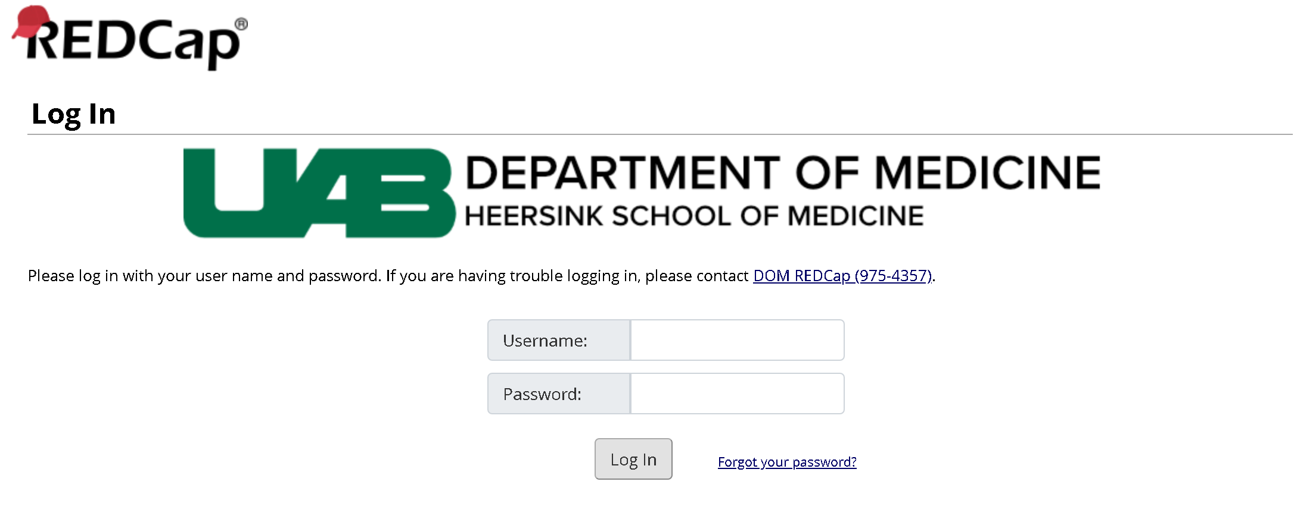

After logging in, you will be taken to this screen below. Click on the “Add/Edit Records” (red circle) to begin entering patient data.

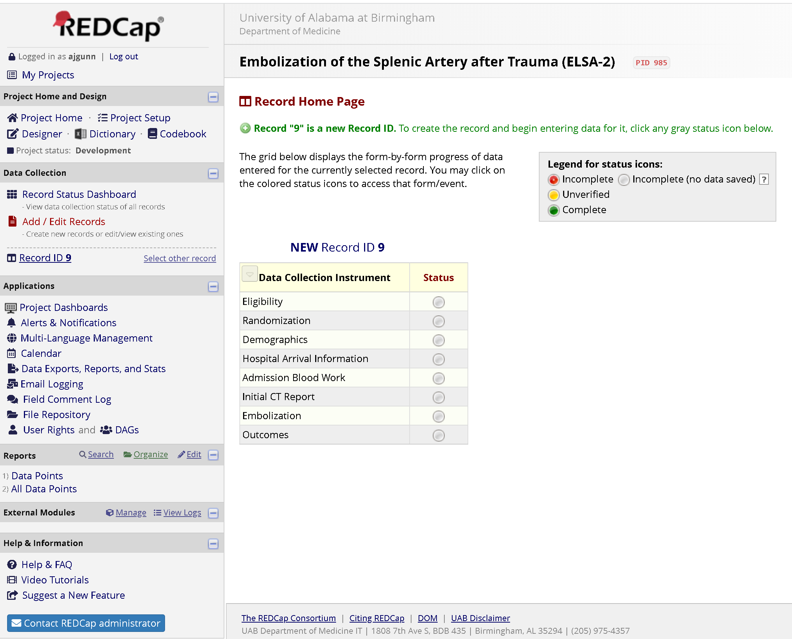

**Section 4 – Screening**

**4.1 Overview**

Subjects will be screened for eligibility to participate in the clinical trial and, after obtaining informed consent, assigned a study ID by REDCap. For randomized subjects, data will be collected from a review of the medical records, the trauma registry, and results of diagnostic studies from admission until 1) post-procedure day 30, 2) the patient expires, or 3) the patient or LAR refused continuation in the trial.

**4.2 Screening**

Staff will be available in the hospital at each center on a 24/7 basis to conduct screening for ELSA 2. The research team at each site will screen all trauma subjects with splenic injury admitted to the ED.

Inclusion criteria:

1. *≥*15 years of age
2. Trauma resulting in grade III or higher splenic injury on contrast-enhanced CT
3. Splenic injury to be treated by non-operative management as decided by attending trauma surgeon and interventional radiologist
4. The attending interventional radiologist determines that the patient will undergo proximal splenic artery embolization with the specific method to be decided by randomization.

Exclusion criteria:

1. Inability to obtain informed consent
2. ≤ 50kg
3. Uncorrectable coagulopathy
4. Patient is immunocompromised
5. Pregnant
6. Breast-feeding
7. Non-English speakers
8. Prisoners

Instructions for completing the Eligibility portion of the Case Report Form (CRF). This information can be obtained from the patient medical record, radiology reports, and laboratory work.

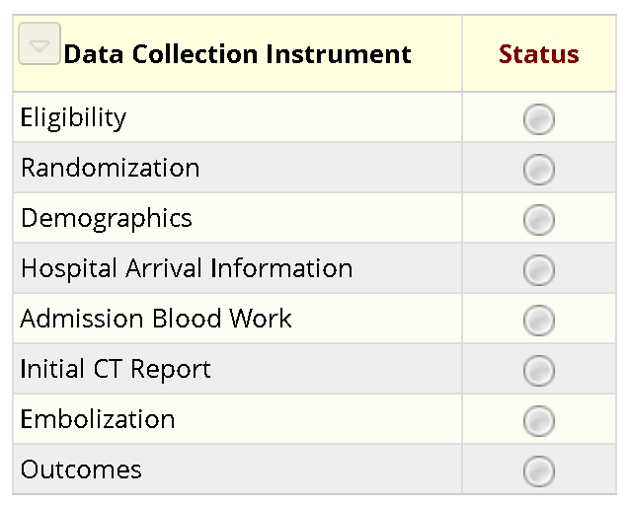

When you click the radio button (red circle), it will open up the form in REDCap. The form begins by asking you each individual question from the inclusion criteria (below). For the inclusion criteria, each time you answer ‘Yes’, a new inclusion criteria will be presented. The inclusion criteria portion of the form continues until the patient meets criteria (i.e., all questions are answered ‘Yes’) or the patient is deemed ineligible. Instructions for answering each of the questions is provided below.

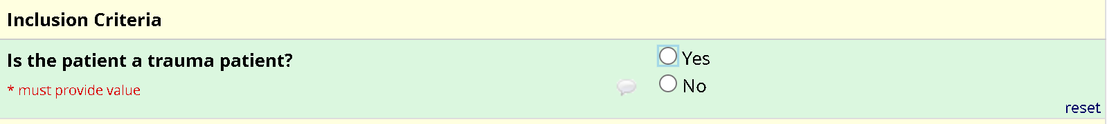

Item: Is the patient a trauma patient? Categorical variable answered as either ‘Yes’ or ‘No’, only trauma patients are eligible for inclusion in ELSA 2.

Item: Does the patient have a Grade III, Grade IV, or Grade V splenic laceration according to AAST criteria on contrast-enhanced CT? Categorical variable answered as either ‘Yes’ or ‘No’, only patients with Grade III, Grade IV, or Grade V splenic lacerations according to AAST criteria are eligible for ELSA 2.

Item: Is the patient >14 years of age? Categorical variable answered as either ‘Yes’ or ‘No’, only patients >14 years of age (i.e., ≥ 15 years of age) are eligible for inclusion in ELSA 2.

Item: Does the patient speak English? Categorical variable answered as either ‘Yes’ or ‘No’, only English speakers are eligible for inclusion in ELSA 2. For clarification, patients do not have to be native English speakers but if the informed consent required the assistance of an English language translator, then the patient would not be eligible for inclusion.

Item: Can someone provide written informed consent? Categorical variable answered as either ‘Yes’ or ‘No’. Written informed consent can be provided by the patient or, if the patient is unable, a physically-present LAR. Consent obtained via telephone communication is not allowed.

After meeting inclusion criteria, the form begins asks each individual question from the exclusion criteria (below). For the exclusion criteria, each time you answer ‘No, a new exclusion criteria will be presented. The exclusion criteria portion of the form continues until the patient meets criteria (i.e., all questions are answered ‘No) or the patient is deemed ineligible. Instructions for answering each of the questions is provided below.

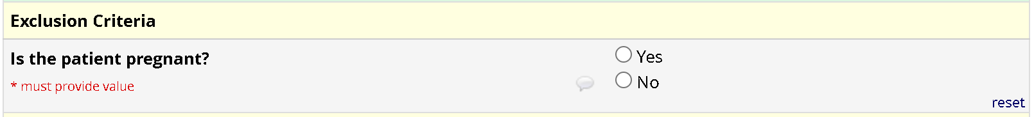

Item: Is the patient pregnant? Categorical variable answered as either ‘Yes’ or ‘No’, pregnant patients are not eligible for inclusion in ELSA 2.

Item: Is the patient breastfeeding? Categorical variable answered as either ‘Yes’ or ‘No’, patients that are breastfeeding are not eligible for inclusion in ELSA 2.

Item: Is the patient a prisoner in a correctional facility? Categorical variable answered as either ‘Yes’ or ‘No’, current prisoners are not eligible for inclusion in ELSA 2.

Once it is determined that the subject is ineligible, data collection will cease. For subjects meeting ELSA 2 eligibility criteria, the site staff will enter the REDCap database to obtain a patient ID number and randomize the patient to a treatment arm (see ‘Randomization’ section).

The data collected up to the time the patient is deemed ineligible will be kept at each site and submitted to the ELSA 2 Trial Office to allow a description of screened patients versus enrolled subjects.

When you are done with the section, make sure to mark the form ‘Complete’ (red circle, below) by clicking on the drop down arrow next to the ‘Incomplete/Complete’ box. At that point, you can click on ‘Save & Exit Form’ if you are done entering data on the subject for the time being or click on ‘Save & Go To Next Form’ to continue entering data on the subject.



**Section 5 – Randomization**

After meeting the above criteria and obtaining written informed consent, the patient will be randomized to either the coil arm or plug arm, using permuted block randomization stratified by center. Randomization will take place electronically, using the trial’s REDCap CRF. Following confirmation of eligibility, the operator will be notified whether the patient has been allocated to the coil or plug arm of the study.

**5.1 Definition of Randomization**

A patient is randomized and enrolled into the ELSA 2 trial when written informed consent is signed and the patient is assigned to a treatment arm via the REDCap CRF.

**5.2 Randomization Steps**

Instructions for completing the Randomization portions of the CRF.



When you click the radio button (red circle), it will open up the form in REDCap.



Make note of the Record ID, which is specific to each patient. Protected health information (PHI) such as the patient’s name or site medical record number (MRN) cannot be contained in the CRF. It is the responsibility of the site PI and site study team to keep an internal record of PHI for each enrolled patient to be able to collect and match study data from each patient.

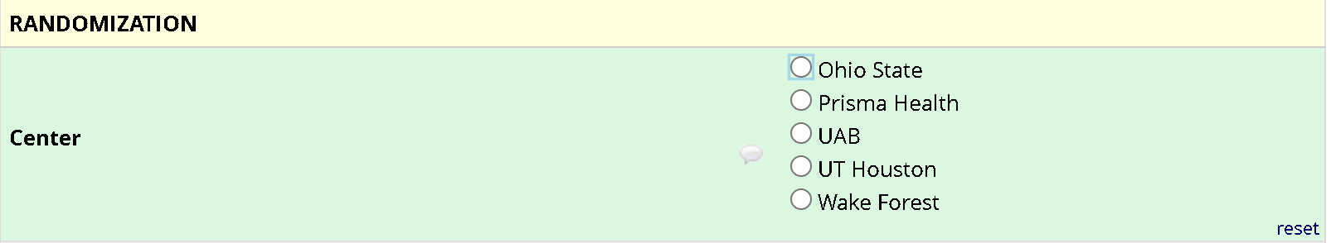

Select your center from the list provided (above).



Click the ‘Randomize’ button (red circle, above). After clicking the button, a window may appear that asks you to assign the patient to a data access group. In that case, assign the patient to your institution. You will then see the below.

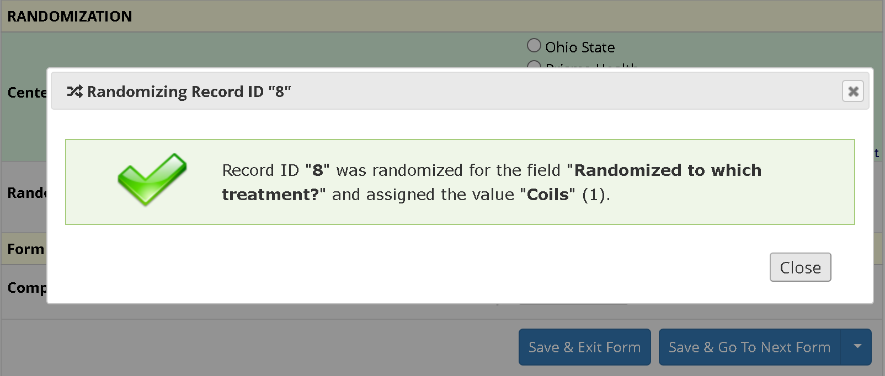

In this case, the patient has been randomized to “Coils”. It will say “Plug” in bold if the patient were to be randomized to plugs. Again, make note of the Record ID, which is specific to each patient and to which group they have been randomized. Protected health information (PHI) such as the patient’s name or site medical record number (MRN) cannot be contained in the CRF. It is the responsibility of the site PI and site study team to keep an internal record of PHI for each enrolled patient to be able to collect and match study data from each patient.

When you are done with the section, make sure to mark the form ‘Complete’ (red circle, below) by clicking on the drop down arrow next to the ‘Incomplete/Complete’ box. At that point, you can click on ‘Save & Exit Form’ if you are done entering data on the subject for the time being or click on ‘Save & Go To Next Form’ to continue entering data on the subject.



**Section 6 – Demographic Information**

Instructions for completing the Demographics portion of the CRF. This information can be obtained from the patient medical record and/or patient themselves.



When you click the radio button (red circle), it will open up the form in REDCap.

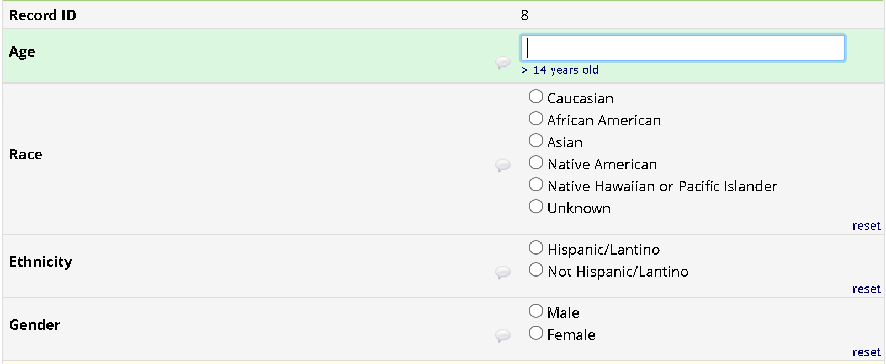

Item: Patient age. Continuous variable reported as the patient’s age in years, with a range of 15-110 provided.

Item: Patient race. Categorical variable recorded according to the definitions below:

* White/Caucasian: A person having origins in any of the original peoples of Europe, the Middle East, or North Africa
* American-Indian/Alaska Native: A person having origins in any of the original peoples of North and South America (including Central America), and who maintains tribal affiliation or community attachment
* Black/African-American: A person having origins in any of the black racial groups of Africa
* Asian: A person having origins in any of the original peoples of the Far East, Southeast Asia, or the Indian subcontinent including, for example, Cambodia, China, India, Japan, Korea, Malaysia, Pakistan, the Philippine Islands, Thailand, and Vietnam
* Native Hawaiian/Pacific Islander: A person having origins in any of the original peoples of Hawaii, Guam, Samoa, or other Pacific Islands
* Other: Identifiable race/ethnicity not described

Item: Patient ethnicity. Categorical variable recorded according to the definitions below:

* Hispanic or Latino: A person of Cuban, Mexican, Puerto Rican, South or Central American, or other Spanish culture or origin
* Non-Hispanic/Non-Latino: A person not qualifying as either Hispanic or Latino according to the definition above

Item: Patient gender. Categorical variable recorded as either ‘Male’ or ‘Female’.

When you are done with the section, make sure to mark the form ‘Complete’ (red circle, below) by clicking on the drop down arrow next to the ‘Incomplete/Complete’ box. At that point, you can click on ‘Save & Exit Form’ if you are done entering data on the subject for the time being or click on ‘Save & Go To Next Form’ to continue entering data on the subject.

* 

**Section 7 – Pre-hospital care and hospital arrival**

Instructions for completing the Pre-Hospital Care and Hospital arrival portions of the CRF. Information for this section can be collected from the patient medical record and site trauma registry.



When you click the radio button (red circle), it will open up the form in REDCap.

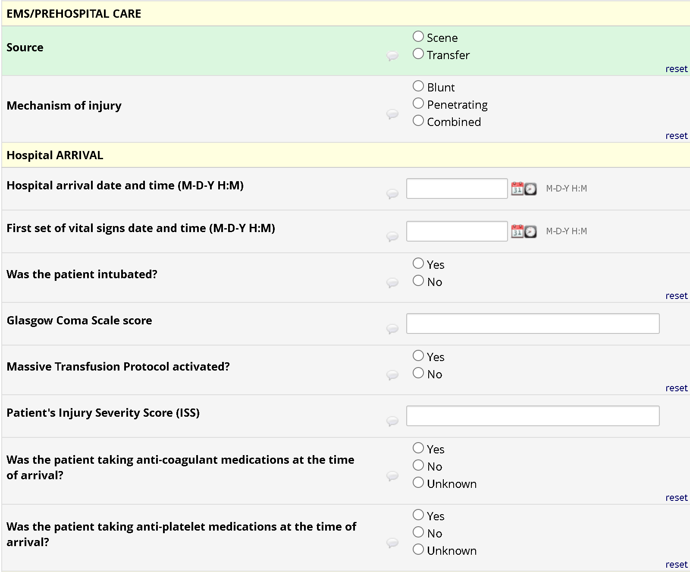

Item: Patient source. Categorical variable describing the source of the patient. “Scene” should be selected when the patient arrives to the site ED directly from the scene of the trauma. “Transfer” should be selected when the patient is transferred to the site ED from another facility.

Item: Mechanism of Injury. Categorical variable describing the patient’s mechanism of splenic injury, with options of “Blunt” for blunt splenic trauma, “Penetrating” for penetrating splenic trauma, or “Combined” when both blunt and penetrating splenic injury are present.

Item: Hospital arrival. Date (categorical variable) in mm/dd/yyyy format and time (continuous variable) in hh:mm 24 hour military format of patient arrival at the site ED.

Item: First set of vital signs. Obtained from the patient medical record or trauma registry. Investigators do not need to independently record patient vital signs.

* Date (categorical variable) in mm/dd/yyyy format and time (continuous variable) in hh:mm 24 hour military format of the first set of vital signs obtained in the site ED.
* Vital signs will be recorded in the database from results provided by the clinical team caring for the patient (i.e., the site investigators are not responsible for obtaining additional vital signs). Vital signs to be recorded in the database will include:
  + Systolic blood pressure (continuous variable), with a range of 20-300 mmHg provided
  + Diastolic blood pressure (continuous variable), with a range of 10-200 mmHg provided
  + Pulse (continuous variable), with a range of 5-220 beats per minute (bpm) provided
  + Temperature (continuous variable), with a range of 31-41° Celsius provided
  + Respiratory rate (continuous variable), with a range of 1-50 respirations per minute provided

Item: Is the patient intubated at the time of arrival to the site ED? Categorical variable recorded as either ‘Yes’ or ‘No’ based on whether the patient is intubated at the time of arrival to the site ED.

Item: Glasgow Coma Score. Continuous variable obtained by site investigators from the initial ED or trauma surgery notes (i.e., site investigators do not need to independently perform this evaluation) or the site trauma registry. If available, scores collected will include:

* + Motor, on a scale from 1-6
  + Eye, on a scale from 1-4
  + Verbal, on a scale from 1-5
  + Total score, on a scale from 3-15

Item: Is the patient on Massive Transfusion Protocol (MTP) at the time of arrival to the site ED? Categorical variable recorded as either ‘Yes’ or ‘No’ based on a review of the patient’s chart.

Item: Is the patient on any vasopressor and/or inotropic medication at time of arrival to the site ED? Categorical variable recorded as either ‘Yes’ or ‘No’ based on a review of the patient’s medication list at the time of arrival to the site ED.

Item: What is the patient’s injury severity score (ISS) at the time of arrival to the site ED? Continuous variable recorded in the database from results provided by the clinical team caring for the patient or the site’s trauma database (i.e., site investigators are not responsible for performing a separate assessment). This information can be found in the patient’s medical record or the site trauma registry. For reference, the calculation of the ISS is provided below:

* Head or neck (including cervical spine), with a range of 1-6 provided
* Face (including the facial skeleton, nose, mouth, eyes, and ears), with a range of 1-6 provided
* Chest (including thoracic spine and diaphragm), with a range of 1-6 provided
* Abdomen or pelvic contrast (including abdominal organ and lumbar spine), with a range of 1-6 provided
* Extremities or pelvic girdle, with a range of 1-6 provided
* External injuries, with a range of 1-6 provided
* Total ISS, with a range of 1-120 provided
  + The total ISS is calculated by 1) identifying the highest score in each of the six defined areas, 2) squaring the highest score in each of the six defined areas, and 3) adding together the three highest scores. For example, if the highest scores in each area were: Head = 3, Face = 3, Chest = 4, Abdomen = 5, Extremities or pelvic girdle = 5, and External injuries = 3. The squares of these values would be Head = 9, Face = 9, Chest = 16, Abdomen = 25, Extremities or pelvic girdle = 25, and External injuries = 9. The three highest values (25, 25, and 16) would be added together for a total ISS of 66.

Item: Is the patient taking any anticoagulant medications at the time of arrival to the site ED? Information is obtained from a review of the patient’s medication list. If ‘Yes’, site investigators can then free text the name of each anticoagulant the patient is taking (see below). Doses are not required.

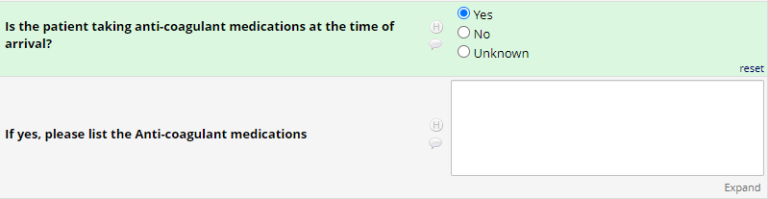

Item: Is the patient taking any antiplatelet medications at the time of arrival to the site ED? Information is obtained from a review of the patient’s medication list. If ‘Yes’, site investigators can then free text the name of each antiplatelet medication the patient is taking (see below). Doses are not required.

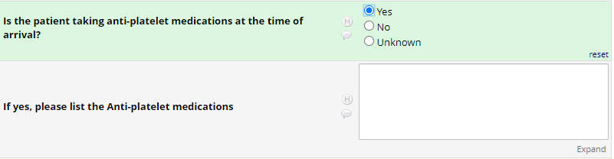

When you are done with the section, make sure to mark the form ‘Complete’ (red circle, below) by clicking on the drop down arrow next to the ‘Incomplete/Complete’ box. At that point, you can click on ‘Save & Exit Form’ if you are done entering data on the subject for the time being or click on ‘Save & Go To Next Form’ to continue entering data on the subject.

* 

**Section 8 – Admission Blood Work**

Instructions for completing the Admission Blood Work portions of the CRF. Information for this section can be collected from the patient medical record.



When you click the radio button (red circle), it will open up the form in REDCap.

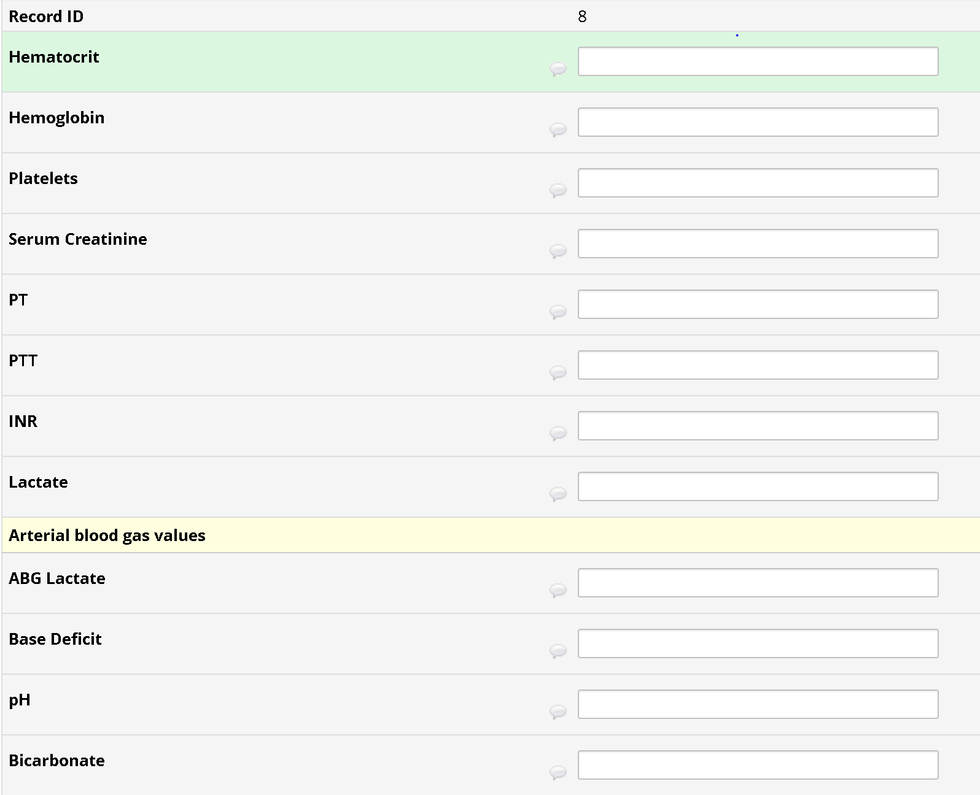

Item: Laboratory work at the time of arrival to the site ED.

Laboratory analyses (continuous variables) will be recorded in the database form results provided by the clinical team caring for the patient. These are routine laboratory studies obtained in many trauma patients for clinical reasons. These are not study-specific laboratory investigations (i.e., site investigators do not need to order additional laboratory testing if certain results are not available). Laboratory analyses to be recorded in the database include:

* White blood cell (WBC) count, with a range of 0.1-35 x 109/L provided
* Hemoglobin (Hgb), with a range of 2-10 g/dL provided
* Hematocrit (Hct), with a range of 10-45% provided
* Platelet count (Plt), with a range of 1-700 x 109/L provided
* Sodium levels, with a range of 100-175 mEq/L provided
* Potassium levels, with a range of 1-8 mEq/L provided
* Bicarbonate levels, with a range of 1-40 mEq/L provided
* Chloride levels, with a range of 75-150 mEq/L provided
* Blood urea nitrogen (BUN), with a range of 5-90 mg/dL provided
* Creatinine (Cr), with a range of 0.1-15 mg/dL provided
* Glucose, with a range of 10-1000 mg/dL provided
* Prothrombin time (PT), with a range of 1-50 seconds provided
* International normalized ratio (INR), with a range of 0.1-15 provided
* Lactate, with a range of 0.1-25 mg/dL provided
* pH from an ABG, with a range of 6-8 provided
* Bicarbonate from an ABG, with a range of 5-40 mEq/L provided
* Lactate from an ABG, with a of 0.1-25 mg/dL provided
* Base deficit from an ABG, with a range of -20 to +20 provided

When you are done with the section, make sure to mark the form ‘Complete’ (red circle, below) by clicking on the drop down arrow next to the ‘Incomplete/Complete’ box. At that point, you can click on ‘Save & Exit Form’ if you are done entering data on the subject for the time being or click on ‘Save & Go To Next Form’ to continue entering data on the subject.

* 

**Section 9 – Initial CT Report**

Instructions for completing the Initial CT Report portions of the CRF. Information for this section can be collected from the CT obtained on patient arrival, which includes review of the radiology report and possible independent review by site investigators. If the patient is transferred with a CT obtained at the transferring institution, the CT obtained at the transferring institution can be used for the study.



When you click the radio button (red circle), it will open up the form in REDCap.

Item: Information from the initial CT. Obtained from imaging reports and images from their initial CT scan. Scans from transferring hospitals can be used, when available. This is imaging obtained as part of routine clinical care and the study team does not need to order additional imaging.

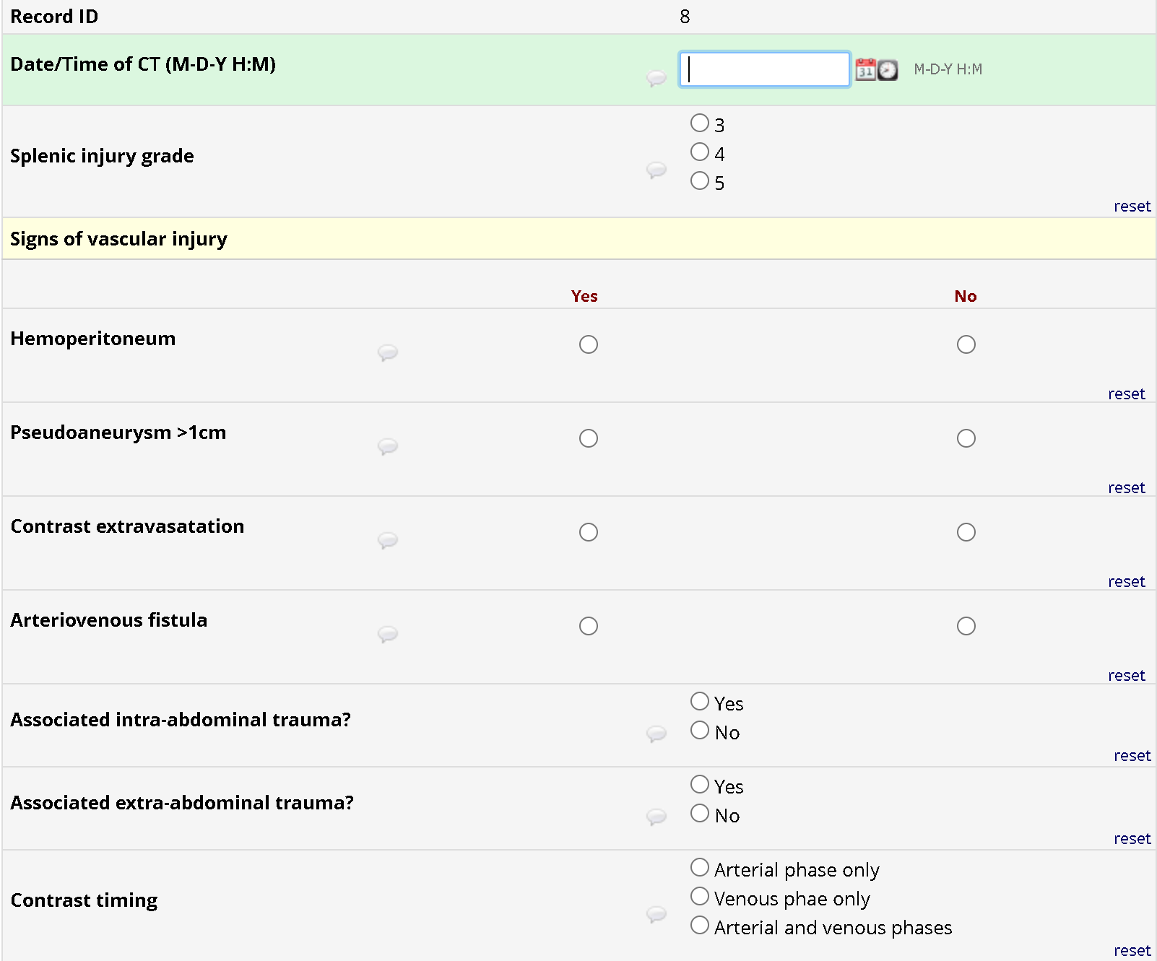

* Date (categorical variable) in mm/dd/yyyy format and time (continuous variable) in hh:mm in 24 hour military format of when the CT was performed.
* Grade of splenic injury according to AAST criteria, with possibility of Grade III, Grade IV, or Grade V injuries; otherwise, the patient is ineligible for enrollment.
* Signs of direct vascular injury on the initial CT are categorical variables recorded as “Yes” if present or “No” if not present for each of the following:
  + Hemoperitoneum
  + Intra-parenchymal pseudoaneurysm ≥1cm in largest diameter
  + Contrast extravasation
  + Arterio-venous fistula (AVF)
* Presence of additional intra-abdominal trauma is a categorical variable recorded as “Yes” if the patient has other areas of intra-abdominal trauma outside the spleen or “No” if the spleen is the only site of intra-abdominal trauma
* Presence of extra-abdominal trauma is a categorical variable recorded as “Yes” if the patient has other areas of traumatic injury outside the abdomen or “No” if the abdomen is the only site of traumatic injury
* The timing of intravenous contrast for the initial CT is a variable where site investigators can record the phases of CT performed during the initial CT. Options of ‘arterial phase only’, ‘venous phase only’, and ‘arterial and venous phases’ provided.

When you are done with the section, make sure to mark the form ‘Complete’ (red circle, below) by clicking on the drop down arrow next to the ‘Incomplete/Complete’ box. At that point, you can click on ‘Save & Exit Form’ if you are done entering data on the subject for the time being or click on ‘Save & Go To Next Form’ to continue entering data on the subject.



**Section 10 – Study Intervention**

**10.1 Study flowchart**



**10.2 Overview of study intervention**

The trial will compare two different devices: Coils (POD®, Penumbra, Alameda, CA, USA), and vascular plugs (Amplatzer™, Abbott Medical, Abbott Park, IL, USA). Coils are FDA-approved endovascular occlusion devices that are deployed through a high-flow micro-catheter (Figure 1). Each type of coil comes in two varieties: 1) a helical coil sized to the vessel diameter that anchors the coil pack in the high-flow vessel and 2) a packing coil that is used to fill in the spaces within the helical coil. A typical proximal splenic artery embolization (pSAE) using coils will involve the deployment of one helical coil followed by packing coils until an adequate coil pack is achieved radiographically. All materials used to deploy the coils are FDA-approved, commercially available, and routinely used in practice.

Fig. 1: Embolization using helical and packing POD coils (images from Penumbra.com).

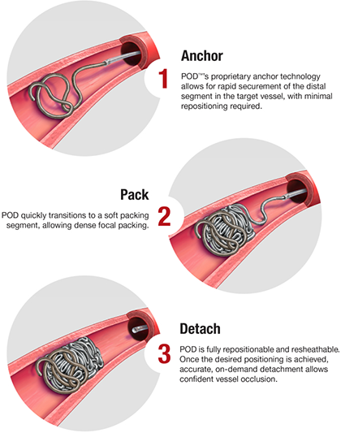

Vascular plugs are FDA-approved endovascular occlusion devices that require an 0.035 inch system within the splenic artery for deployment (Figure 2). The Amplatzer™ IV vascular plug can be deployed through a traditional 5F diagnostic catheter. However, the largest Amplatzer™ IV vascular plug is only 8 mm in size, which may be too small for some splenic arteries. In these cases, a larger Amplatzer™ II vascular plug is needed although these vascular plugs require a larger system for deployment (e.g., guiding catheters or vascular sheaths). All materials needed to deploy both the Amplatzer™ II and IV plugs are FDA-approved, commercially available, and routinely used in practice.

Fig. 2: Amplatzer IV VP (from St. Jude Medical).

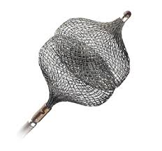 F

**10.3 Splenic artery embolization procedure**

10.3.1 Operators. An attending interventional radiologist or surgeon will perform all pSAE procedures.

10.3.2 Anesthesia. Operators can decide whether to use moderate conscious sedation or general anesthesia depending on the patient’s condition. Local anesthesia will be achieved with lidocaine or a similar drug.

10.3.3 Vascular access. The vascular access site is prepared and draped in standard sterile fashion. The right common femoral artery is the most commonly used vascular access for splenic artery embolization but other arteries may be used for certain patients, as is common in standard clinical practice.

10.3.4 Celiac axis angiogram. A celiac axis angiogram is performed through a standard diagnostic catheter. The attending interventional radiologist or surgeon will choose the diagnostic catheter based on his/her preference. The attending interventional radiologist or surgeon will review the celiac angiogram to identify an appropriate landing zone in the mid-splenic artery distal to the origin of the dorsal pancreatic artery but proximal to the origin of the pancreaticomagna artery, preserving collateral flow to the spleen via the transverse pancreatic artery, which is standard practice for a pSAE. The vessel’s diameter at the location of embolization will be measured and recorded.

10.3.5 Coil embolization. For patients randomized to coil embolization, a high-flow micro-catheter is navigated to the location of embolization with the assistance of a micro-wire. The micro-wire and micro-catheter combination will be left to the discretion of the attending interventional radiologist or surgeon. Once the micro-catheter is in place, a splenic angiogram will be performed to confirm location and assess for pseudoaneurysms, AVFs, or contrast extravasation. Coil embolization will then proceed per the manufacturer’s instructions for use. In short, the first coil used is a sized anchoring coil to stabilize the coil pack in the mid-splenic artery. Subsequently, the anchoring coil is filled with packing coils. **The operator places any number of coils required to achieve an adequate radiographic coil pack, as is standard practice**.

10.3.6 Plug embolization. For patients randomized to vascular plug embolization, the appropriately-sized catheter or sheath is advanced to the location of embolization. The tools used to access the mid-splenic artery will vary depending on the operator’s experience and patient anatomy. Once the catheter or sheath is in place, a splenic angiogram will be performed to confirm location and assess for pseudoaneurysms, AVFs, or contrast extravasation. Vascular plug embolization will then proceed per the manufacturer’s instructions for use. As is standard practice, only a single vascular plug is typically deployed.

10.3.7 Time to hemostasis. For both coil and vascular plug embolization, absence of flow at the level of the embolic agent in the mid-splenic artery will serve as the endpoint for satisfactory hemostasis. Regardless of the embolic used the interventional radiologist or surgeon will perform intermittent non-subtracted angiograms (one per minute) to determine if stasis has been achieved. Non-subtracted angiograms are used initially to limit radiation exposure to the patient and staff. If hemostasis is suspected on the non-subtracted angiogram, a digital subtraction angiogram is then immediately performed for confirmation. If stasis is not confirmed, operators will continue to check for stasis with non-subtracted angiograms every minute. If hemostasis is confirmed, the time to hemostasis will be recorded. The time to hemostasis will be calculated from the time of vascular plug deployment or time of last coil deployment until hemostasis was achieved in the mid-splenic artery. For patients randomized to coils, operators will not be allowed to check for stasis with non-subtracted angiograms until they have determined to have achieved a radiographically-adequate coil pack.

10.3.8 Use of secondary hemostatic agents. If hemostasis is not achieved after 15 minutes, then a secondary embolic can be employed. If a secondary embolic agent such as particles or gelfoam is needed for patients in either group, this will be recorded. The time to stasis will be recorded as outlined above. All potential secondary embolic agents are FDA-approved devices, commercially available, and routinely used in practice at all participating centers.

10.3.9 Technical failure. If the operator is unable to navigate into the mid-splenic artery with the necessary tools to perform the required embolization, this will also be recorded. In this circumstance, the procedure will be recorded as a technical failure and the operator will then proceed to treat the patient as he/she deems appropriate. ***As such, all patients will receive standard of care therapy in this trial.***

10.3.10 Arteriotomy closure. Catheters and wires will be removed after hemostasis is obtained in the mid-splenic artery. The arteriotomy will be closed with a FDA-approved, commercially available vascular closure device, if possible. Alternatively, hemostasis at the arteriotomy will be obtained with manual pressure.

**10.4 Instructions for completing the Embolization Procedure portion of the CRF**

Please note that the Embolization Procedure portion of the CRF does not need to be completed at the time of the procedure as long as all the necessary information is recorded in the procedural record, images, and/or dictation.



Click on the radio button (red circle, above) to open the form.

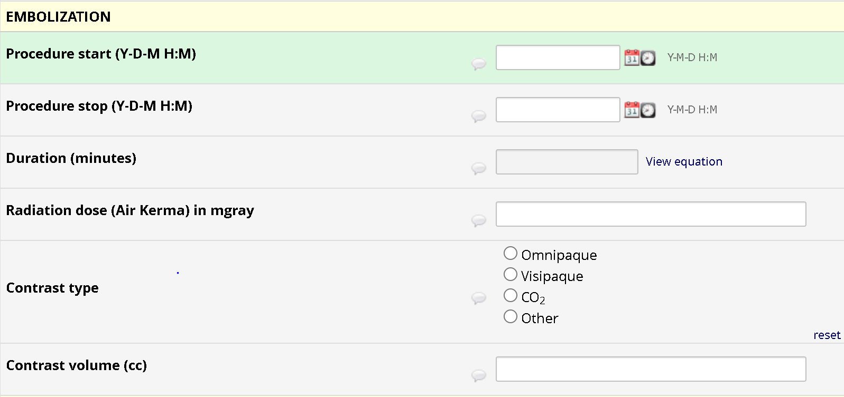

Item: Procedure start time. Defined as the time of local lidocaine administration. Recorded in hh:mm 24 hour military format.

Item: Procedure end time. Defined as the time of catheter and wire removal from the patient’s body. This *does not* include time for arteriotomy closure or manual hemostasis at the arteriotomy site. Recorded in hh:mm 24 hour military format.

Item: Duration of procedure. Continuous variable calculated as the difference between procedure end time and procedure start time. Recorded in minutes.

Item: Radiation dose. Continuous variable defined as the dose area product (DAP) from the procedure. Recorded in milliGray (mGy).

Item: Contrast used. Both the type (categorical variable) and volume (continuous variable) of contrast administered during the embolization procedure. The type of contrast will be free text while the volume will be recorded in cc, with a range of 1-700 mL provided.

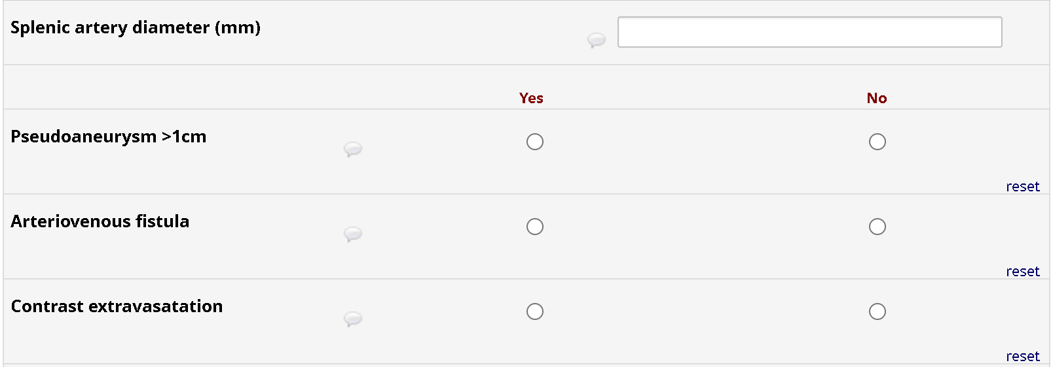

Item: Splenic artery diameter: Continuous variable representing the diameter of the splenic artery at the embolization landing zone in the mid-splenic artery, with a range of 1-30mm provided.

Item: Pseudoaneurysm ≥1cm: Categorical variable describing the presence of an intra-parenchymal splenic pseudoaneurysm measuring ≥1cm. This is recorded as “Yes” if an intra-parenchymal pseudoaneurysm measuring ≥1cm exists and “No” if it does not.

Item: Arteriovenous fistula (AVF): Categorical variable describing the presence of an AVF within the spleen. This is recorded as “Yes” if an AVF is identified and “No” if it is not identified.

Item: Contrast extravasation: Categorical variable describing arterial contrast extravasation from a splenic arterial branch during catheter-based angiography. This is recorded as “Yes” if contrast extravasation is identified and “No” if it is not identified.



Item: Primary embolic: This categorical variable describes the primary embolic agent deployed in the mid-splenic artery. Record “Plug” if the primary embolic agent was a plug and “Coil” if the primary embolic agent was a coil. If the patient was randomized to the coil group and coils were the primary embolic, no other question will appear for this field. If the patient was randomized to the coil group and a plug was used as the primary embolic, an additional item will be presented requesting the reason why the primary embolic differed from the prescribed (randomized) embolic (see below).

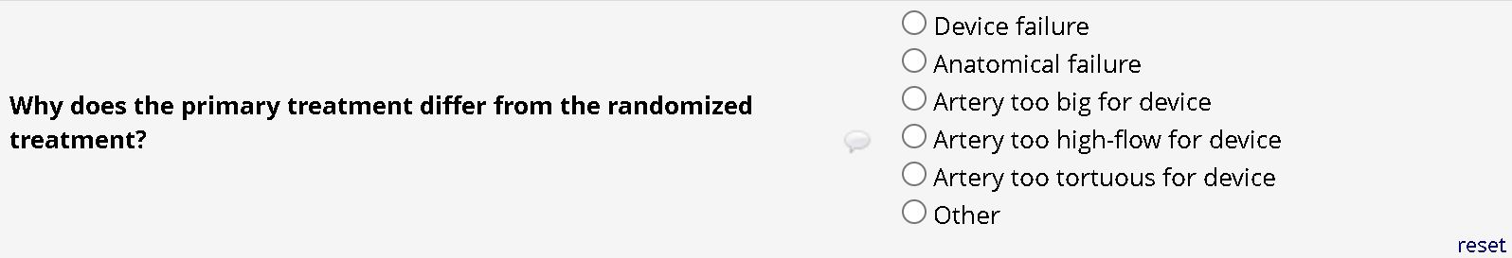

Please select the reason from those listed above. If ‘Other’ is selected, a free text box will appear asking you to specify the reason why the primary embolic differed from the prescribed (randomized) embolic. Similarly, if the patient was randomized to the plug group but coils were used as the primary embolic, the above question will appear requesting why the primary embolic differed from the prescribed (randomized) embolic.



If coils were used as the primary embolic agent, the above item will appear asking how many coils were used. Click on the arrow (red circle), and a drop down will appear allowing you to select the number of coils used. You can select up to 15 coils.

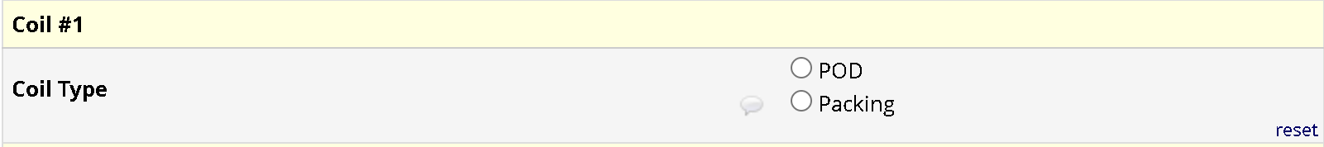

For each coil used, select the type of coil. The two types of coils for this study include a Penumbra POD coil and the Penumbra Packing coils.

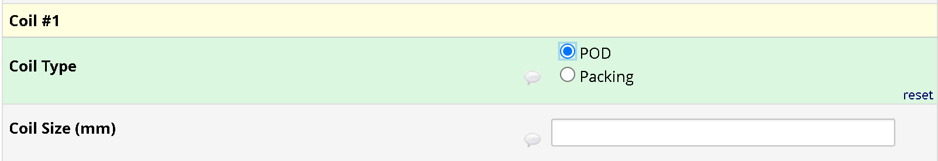

If a POD coil is used, you will then be asked to provide the coil size (i.e., diameter) (see above). This is a continuous variable, with a range of 2-24mm provided.

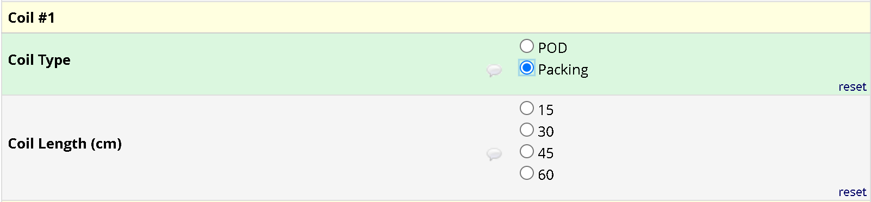

If a packing coil is used, you will be asked to select the coil length (see above). This is a categorical variable with 15cm, 30cm, 45cm, and 60cm provided.

Repeat this process for every coil used.

If a plug was used as the primary embolic agent, the below item will appear asking how many plugs were used. Click on the number of plugs used. ***Most cases should only employ one plug; however, operators do have the ability to use additional plugs, if he/she feels it is necessary****.* You can select up to three plugs.



For each plug used, select the type of plug (categorical variable) and list its diameter (continuous variable) (see below). The two types of plugs for this study include the Amplatzer II and Amplatzer IV plugs. A range of 2-24mm for diameters is provided.

Repeat this process for each plug used.

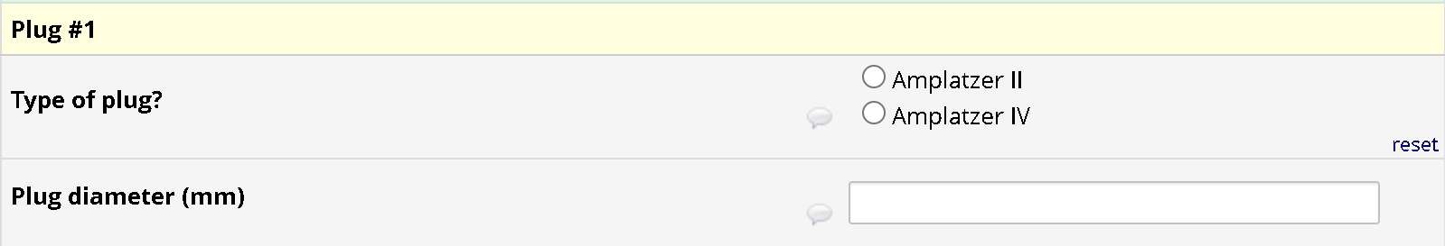



Item: Primary technical success. ***Primary technical success is the primary endpoint of the trial***. This categorical variable is defined as the ability to deploy the embolic to which the patient was randomized in the mid-splenic artery and achieve hemostasis in the mid-splenic artery within 15 minutes of deployment. For both coil and vascular plug embolization, absence of flow at the level of the embolic agent in the mid-splenic artery will serve as the endpoint for satisfactory hemostasis. This variable will be recorded as “Yes” if primary technical success was achieved and “No” if primary technical success was not achieved. Examples are provided for reference:

* Example 1: Patient is randomized to the vascular plug arm. After successful deployment of the vascular plug, hemostasis is achieved in the mid-splenic artery after 10 minutes. No other embolics are used. This would be recorded as ***primary technical success for the vascular plug***.
* Example 2: Patient is randomized to the vascular plug arm. After successful deployment of the vascular plug, hemostasis is not achieved in the mid-splenic artery after 15 minutes. The operator decides to use an additional embolic. This would be recorded as ***primary technical failure for the vascular plug***.
* Example 3: Patient is randomized to the vascular plug arm. Due to patient anatomy, the operator does not feel that he/she can safely deploy the plug. Instead, he/she decides to treat the patient with endovascular coils. This would be recorded as ***primary technical failure for the vascular plug***.
* Example 4: Patient is randomized to the coil arm. After successful deployment of enough coils to achieve a radiographically-acceptable coil pack, hemostasis is achieved in the mid-splenic artery after 10 minutes. No other embolics are used. This would be recorded as ***primary technical success for the coils***.
* Example 5: Patient is randomized to the coil arm. After successful deployment of enough coils to achieve a radiographically-acceptable coil pack, hemostasis is not achieved in the mid-splenic artery after 15 minutes. The operator decides to use an additional, non-coil embolic agent. This would be recorded as ***primary technical failure for the coils***.
* Example 6: Patient is randomized to the coil arm. Due to patient anatomy, the operator does not feel that he/she can safely deploy the coils. Instead, he/she decides to treat the patient with a vascular plug. This would be recorded as ***primary technical failure for the coils***.

If ‘Yes’ is selected (i.e., primary technical success was achieved), then no other questions will appear for this item. If ‘No’ is selected (i.e., primary technical success was not achieved), then additional information (below) is required.



Item: Was a secondary embolic treatment required? This categorical variable is defined as the use of a secondary embolic therapy in order to achieve hemostasis in the mid-splenic artery **when primary technical success** **was not achieved**. Record “Yes” if a secondary embolic was used (examples provided below) or “No” if a secondary embolic was not used.

Examples of using a secondary embolic agent:

* Example 1: Patient is randomized to the vascular plug arm. After successful deployment of the vascular plug, hemostasis has not been achieved after 15 minutes. The operator decides to add coils, gelatin sponge slurry, or particles in order to achieve hemostasis. This would be recorded as a ***primary technical failure for the plug with use of a secondary embolic agent***.
* Example 2: Patient is randomized to the vascular plug arm. Due to patient anatomy, the operator does not feel that he/she can safely deploy the plug. Instead, he/she decides to treat the patient with endovascular coils. This would be recorded as ***primary technical failure for the vascular plug with use of a secondary embolic agent***.
* Example 3: Patient is randomized to the coil arm. After successful deployment of enough coils to achieve a radiographically-acceptable coil pack, hemostasis has not been achieved after 15 minutes. The operator decides to add plugs, gelatin sponge slurry, or particles in order to achieve hemostasis. This would be recorded as a ***primary technical failure for the coils*** ***with use of a secondary embolic agent***.
* Example 4: Patient is randomized to the coil arm. Due to patient anatomy, the operator does not feel that he/she can safely deploy the coils. Instead, he/she decides to treat the patient with a vascular plug. This would be recorded as ***primary technical failure for the coils with use of a secondary embolic agent***.

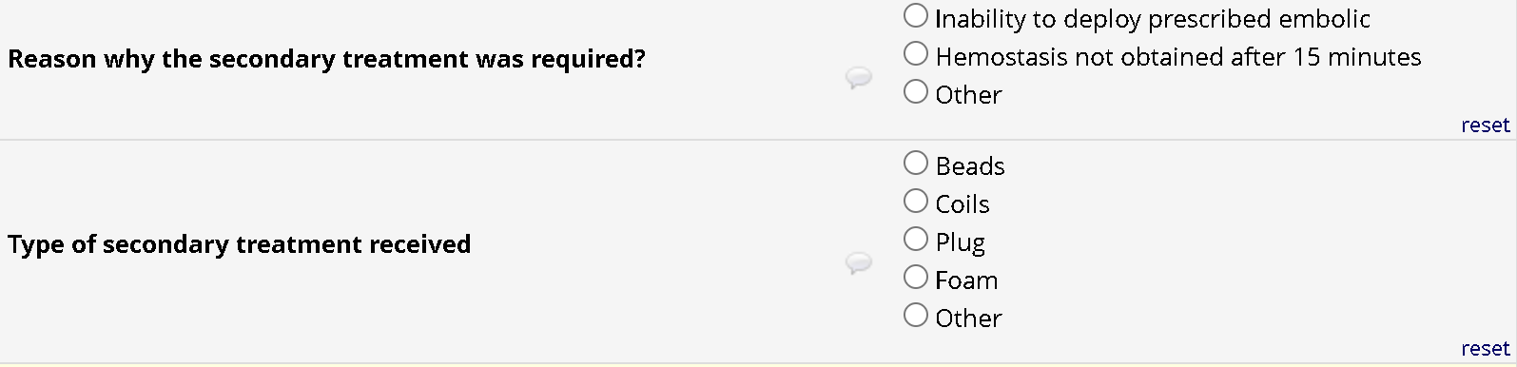

After answering ‘Yes’ to whether a secondary embolic treatment was required after *failing to achieve primary technical success,* you will be asked to identify the reason a secondary embolic treatment was needed (above). Select the most appropriate response. If ‘Other’ is selected, a box will appear that allows you to free text the reason. You will also be asked to select the secondary embolic agent with beads (i.e., microspheres), coils, plugs, foam (i.e., gelatin sponge slurry), and Other provided as options.

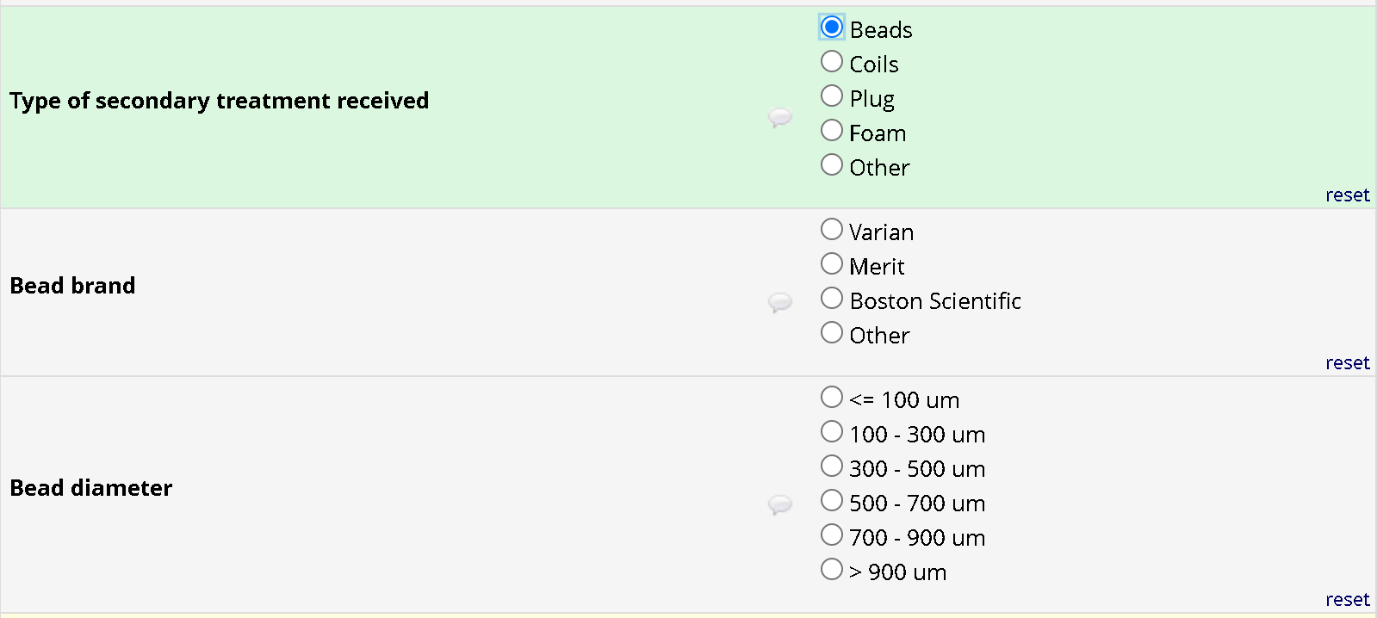

If bead (i.e., microspheres) are selected as the secondary embolic agent, additional items will appear (above). Select the brand of bead used (categorical variable) and the bead diameter (categorical variable). If ‘Other’ is selected for bead brand, a box will appear that allows you to free text the bead brand.

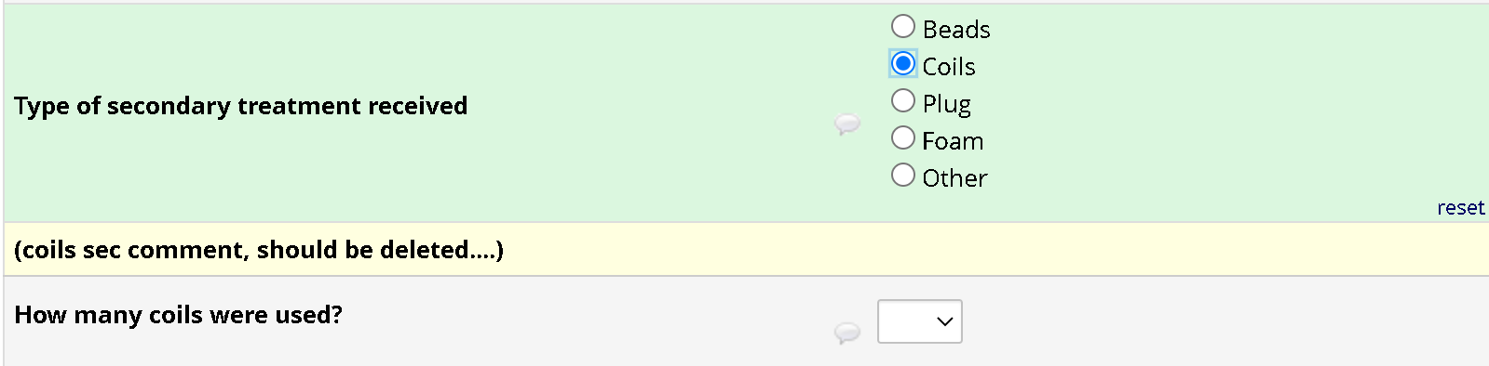

If coils are selected as the secondary embolic agent, an additional item will appear requesting specification of the number of coils used (above). Click on the drop down arrow (red circle above) and select the number of coils used as a secondary embolic agent. You can select up to 15 coils.



For each coil used, select the type of coil (above). The two types of coils for this study include a Penumbra POD coil and the Penumbra Packing coils.



If a POD coil is used, you will then be asked to provide the coil size (i.e., diameter) (see above). This is a continuous variable, with a range of 2-24mm provided.



If a packing coil is used, you will be asked to select the coil length (see above). This is a categorical variable with 15cm, 30cm, 45cm, and 60cm provided.

Repeat this process for every coil used as a secondary embolic agent.





If plugs are selected as the secondary embolic agent, an additional item will appear requesting specification of the number of plugs used (above). Click on the drop down arrow (red circle above) and select the number of plugs used as a secondary embolic agent. You can select up to three plugs. ***Most cases should only employ one plug as a secondary embolic agent; however, operators do have the ability to use additional plugs, if he/she feels it is necessary.***

For each plug used, select the type of plug (categorical variable) and list its diameter (continuous variable) (see below). The two types of plugs for this study include the Amplatzer II and Amplatzer IV plugs. A range of 2-24mm for diameters is provided.

Repeat this process for each plug used.





If ‘foam’ (i.e., a gelatin sponge slurry) is selected, no other information is required (above). If ‘Other’ is selected, a box will appear that allows you to free text the secondary embolic not listed here.



‘No’ should be selected for whether a secondary treatment was required if:

1. Primary technical success was not achieved, **AND**
2. No other attempts at placing embolic material in the splenic artery was attempted during the procedure

When a secondary treatment was required (e.g., patients that did not achieve primary technical success), an item appears that inquires about secondary technical success (see below)



Item: Secondary treatment technical success: This categorical variable is defined as the ability to deploy ***any embolic*** in the mid-splenic artery and achieving **hemostasis *at any time point* in patients who did not achieve primary technical success**. Absence of flow at the level of the embolic agent in the mid-splenic artery will serve as the endpoint for satisfactory hemostasis. This variable will be recorded as “Yes” if secondary technical success was achieved and “No” if secondary technical success was not achieved. Examples are provided for reference:

* Example 1: Patient is randomized to the vascular plug arm. After successful deployment of the vascular plug, hemostasis is not achieved in the mid-splenic artery after 15 minutes. The operator decides to use an additional embolic, which subsequently achieves hemostasis in the mid-splenic artery. This would be recorded as ***primary technical failure for the vascular plug*** ***with use of a secondary embolic agent to achieve secondary treatment technical success*.**
* Example 2: Patient is randomized to the vascular plug arm. Due to patient anatomy, the operator does not feel that he/she can safely deploy the plug. Instead, he/she decides to treat the patient with coils. This would be recorded as ***primary technical failure for the plug with use of a secondary embolic agent to achieve secondary treatment technical success.***
* Example 3: Patient is randomized to the coil arm. After successful deployment of enough coils to achieve a radiographically-acceptable coil pack, hemostasis is not achieved in the mid-splenic artery after 15 minutes. The operator decides to use an additional, non-coil embolic agent. This would be recorded as ***primary technical failure for the coils with use of a secondary embolic agent to achieve secondary treatment technical success.***
* Example 4: Patient is randomized to the coil arm. Due to patient anatomy, the operator does not feel that he/she can safely deploy the coils. Instead, he/she decides to treat the patient with a vascular plug. This would be recorded as ***primary technical failure for the coils with use of a secondary embolic agent to achieve secondary treatment technical success.***

If ‘Yes’ is selected (i.e., secondary technical success was achieved), then no other questions will appear for this item. If ‘No’ is selected (i.e., secondary technical success was not achieved), then additional information (below) is required.

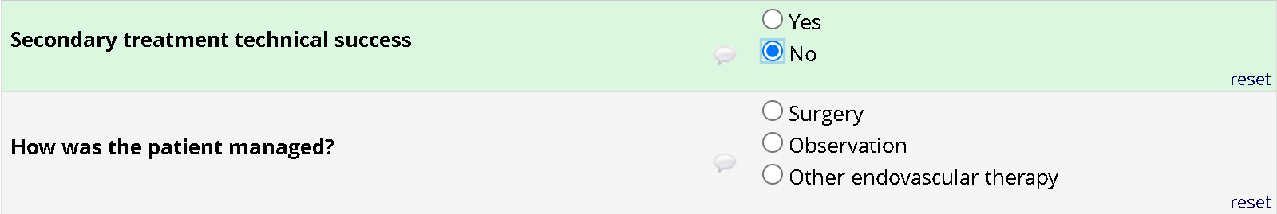

For patients that did not achieve secondary technical success, select how the patient was managed. Provided options include surgery, observation, or other endovascular therapy (i.e., non-embolic therapy). If ‘Other endovascular therapy’ is selected, a box will appear that will allow you to free text the endovascular therapy used.



Item: Time to hemostasis.

* **For patients that achieved primary technical success:** The time to hemostasis (continuous variable) will be calculated from the time of vascular plug deployment or time of last coil deployment until hemostasis was achieved in the mid-splenic artery in minutes. For patients randomized to coils, operators will not be allowed to check for stasis with non-subtracted angiograms until they have determined to have achieved a radiographically-adequate coil pack.
* **For patients that did not achieve primary technical success, but did achieve secondary technical success:** The time to hemostasis (continuous variable) will be calculated from the *time of secondary embolic deployment until hemostasis was achieved in the mid-splenic artery in minutes*. When coils are used as a secondary embolic agent, operators will not be allowed to check for stasis with non-subtracted angiograms until they have determined to have achieved a radiographically-adequate coil pack.
* **For patients that did not achieve primary or secondary technical success:** Item should be left blank.



Item: Intra procedural complications. This categorical variable is defined as the presence of intra procedural complications. Record ‘Yes’ if there was an intra-procedural complication or ‘No’ if there was no intra-procedural complication. If ‘No’ is selected, no additional information is required.

If ‘Yes’ is selected, an additional item will appear (below) to document additional information.

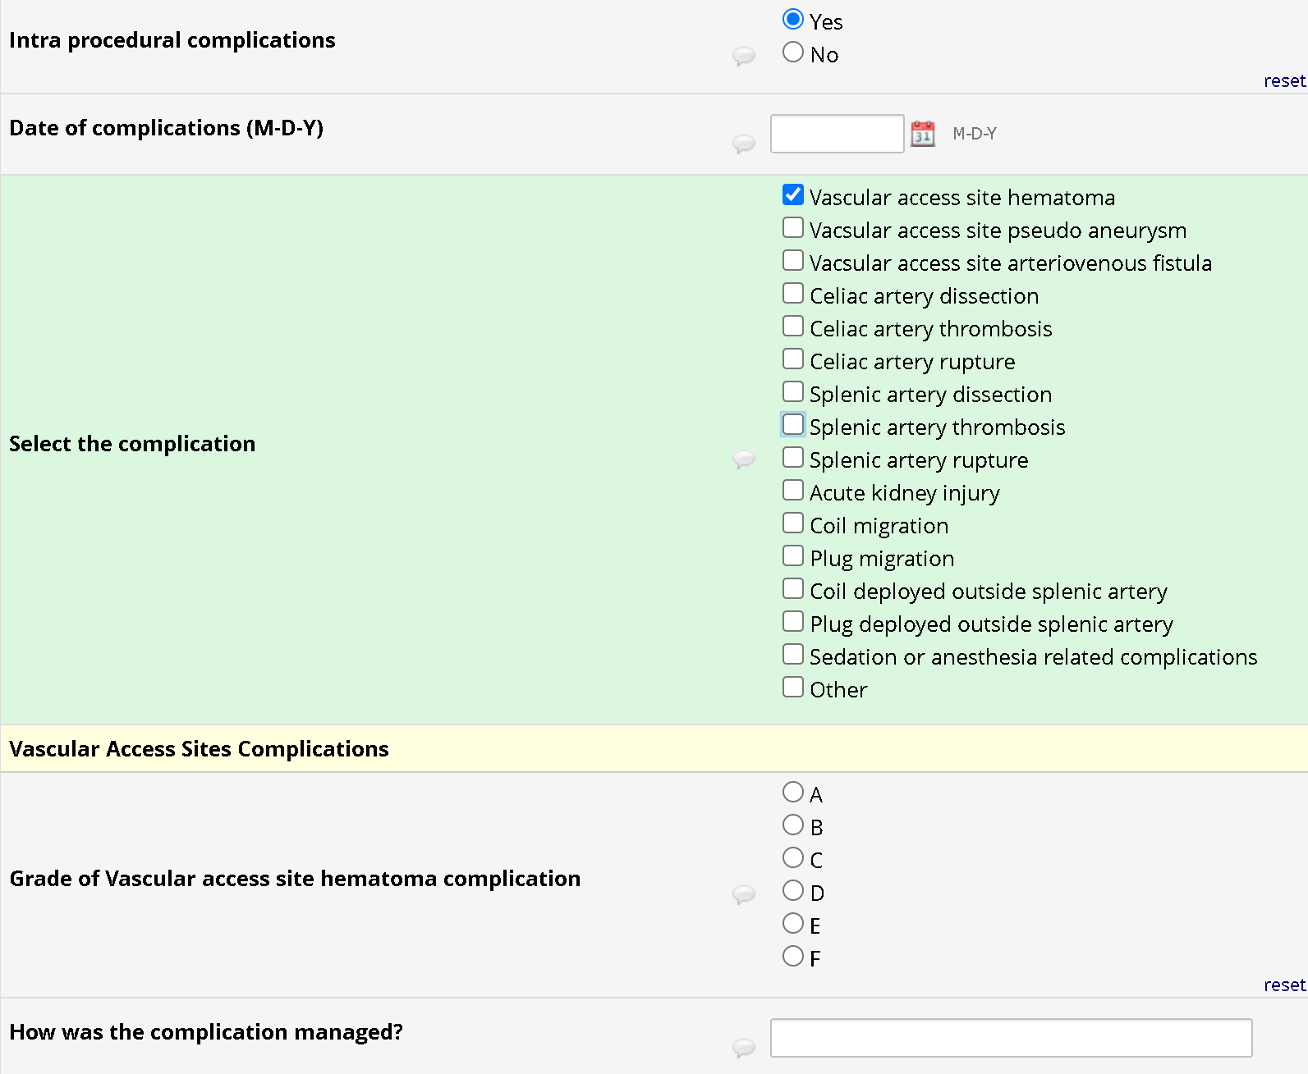

Provide the date of the complication, which typically should be the date of the procedure.

From the list of complications, select all that apply. If ‘Other’ is selected, a box will appear that will allow you to free text a complication if it is not listed here.

For each complication selected, provide the grade of complication (A-F) according to Society of Interventional Radiology (SIR) criteria.

Finally, free text in the space provided how the complication was managed (e.g., splenic artery dissection treated with stent placement; or coil migration treated with endovascular snare; or sedation-related hypoxemia treated with reversal agents).

When you are done with the section, make sure to mark the form ‘Complete’ (red circle, below) by clicking on the drop down arrow next to the ‘Incomplete/Complete’ box. At that point, you can click on ‘Save & Exit Form’ if you are done entering data on the subject for the time being or click on ‘Save & Go To Next Form’ to continue entering data on the subject.



**Section 11 – Post-procedure care**

**11.1 Overview of post-procedure care**

After splenic artery embolization, patients will be transferred back to a clinical unit for continued observation. Depending on the patient’s clinical condition, post-procedure care could be performed in an intensive care unit (ICU), step-down unit, or on a regular medical/surgical floor. Post-procedure care will be dictated by the clinical team caring for the patient according to institutional protocols and best practices. Site investigators will be available 24/7 to follow subjects enrolled into ELSA 2.

**11.2 Informed consent follow-up**

If written informed consent was obtained from a LAR, a member of the study team will follow up with the patient within 96 hours of enrollment so they can review and sign the consent forms in person. At that time point, if the patient is still unable to provide written informed consent, a member of the study team will continue to re-assess the patient’s ability to provide written informed consent every few days.

**11.3 Follow-up at 30 days**

Patients will exit the study 30 days after splenic artery embolization. A member of the study team will review the patient’s medical record for necessary data points. If discharge occurs before hospital day 30 and the subject is discharged to a hospice, nursing home or other healthcare provider, research staff will contact the facility to ascertain the subject’s status. If the subject was discharged to his/her usual residence before day 30, the research staff will contact the subject or their family/legally authorized representative (LAR). For subjects discharged to another facility, the clinical research staff should complete an authorization form to release protected health information (PHI) and obtain signatures from the subject or LAR prior to discharge. A copy of the signed authorization form and study consent will be provided to the facility for release of PHI. Clinical sites will follow local and state HIPPA guidelines for release of PHI for research.

If vital status remains unknown, the clinical site will request periodic searches for the subject’s social security number in the Social Security Master Death Index, the respective State Health Department’s vital statistics/mortality database, and the mortality databases of a credit reporting agency, e.g., Experian. For subjects not reported as deceased by these sources by day 30 following ED admission, batch searches of the mortality databases will continue every quarter until trial close-out.

**11.4 Instructions for completing the Outcomes portion of the CRF**

Information for this section can be obtained from patient interview, the patient medical record, and/or the site trauma registry.



Click on the radio button (red circle, above) to open the form.

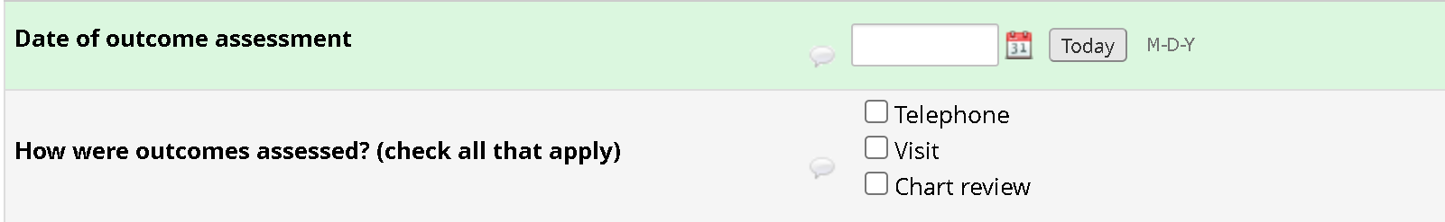

Item: Date of outcome assessment. Enter the date in mm/dd/yyyy format that 30-day outcomes were assessed

Item: How were outcomes assessed? Indicate how 30-day outcomes were assessed, either by telephone, in-person visit, and/or chart review only. Please mark all that apply.

Item: Transfusion requirements in first 24 hours after injury. This categorical variable represents the transfusion of any blood products within the first 24 hours after injury. Check ‘Yes’ if the patient received transfusion of any blood products within the first 24 hours after injury. Check ‘No’ if no transfusions were given in the first 24 hours after injury. If ‘No’ is selected, no other information is required for this item. If ‘Yes’ is selected, then provide the number of units of red blood cells (RBC), fresh frozen plasma (FFP), platelets (PLT), cryoprecipitate, and whole blood given in the first 24 hours after injury (below).

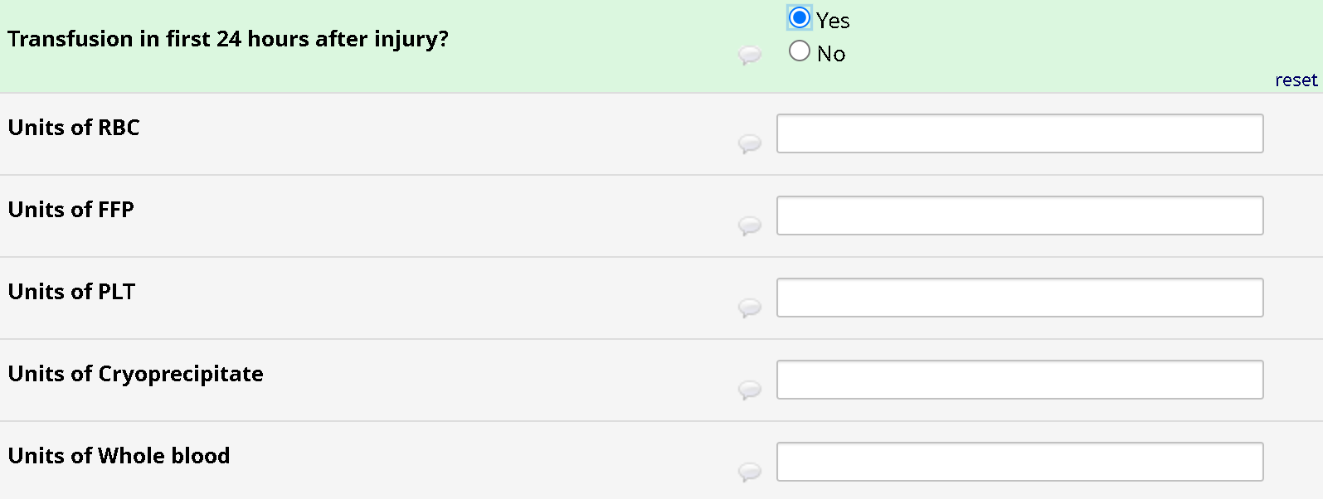

Item: Transfusion requirements after splenic artery embolization. This categorical variable represents the transfusion of any blood products between splenic artery embolization and the 30-day study exit assessment. Check ‘Yes’ if the patient received transfusion of any blood products after splenic artery embolization but prior to the 30-day study exit assessment. Check ‘No’ if no transfusions were given after splenic artery embolization. If ‘No’ is selected, no other information is required for this item. If ‘Yes’ is selected, then provide the number of units of red blood cells (RBC), fresh frozen plasma (FFP), platelets (PLT), cryoprecipitate, and whole blood given between splenic artery embolization and the 30-day study exit assessment (below).

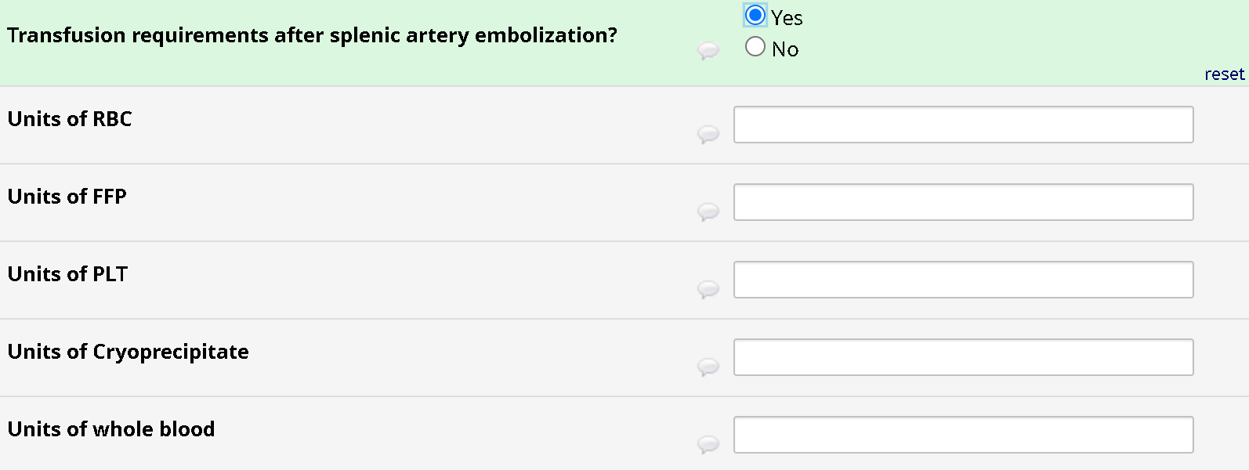

Item: Transfusion requirements during entire hospital stay. This categorical variable represents the transfusion of any blood products during the patient’s hospital stay. Check ‘Yes’ if the patient received transfusion of any blood products during their hospitalization. Check ‘No’ if no transfusions were given during their hospitalization. If ‘No’ is selected, no other information is required for this item. If ‘Yes’ is selected, then provide the number of units of red blood cells (RBC), fresh frozen plasma (FFP), platelets (PLT), cryoprecipitate, and whole blood given during their entire hospital stay (below).

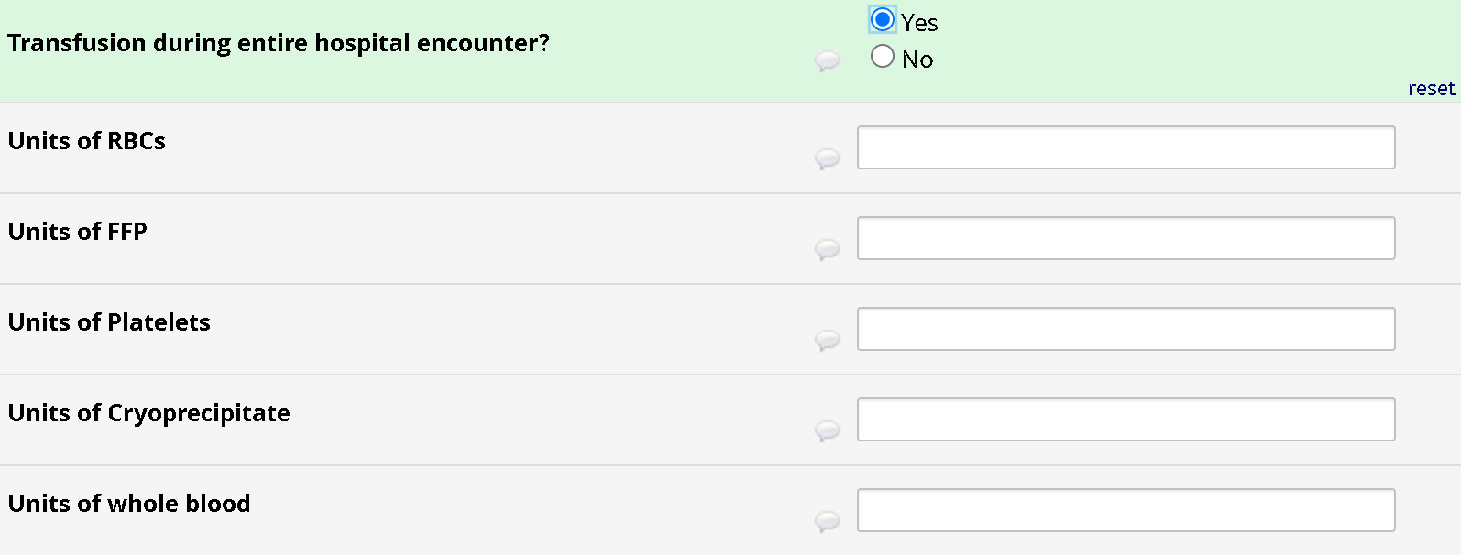

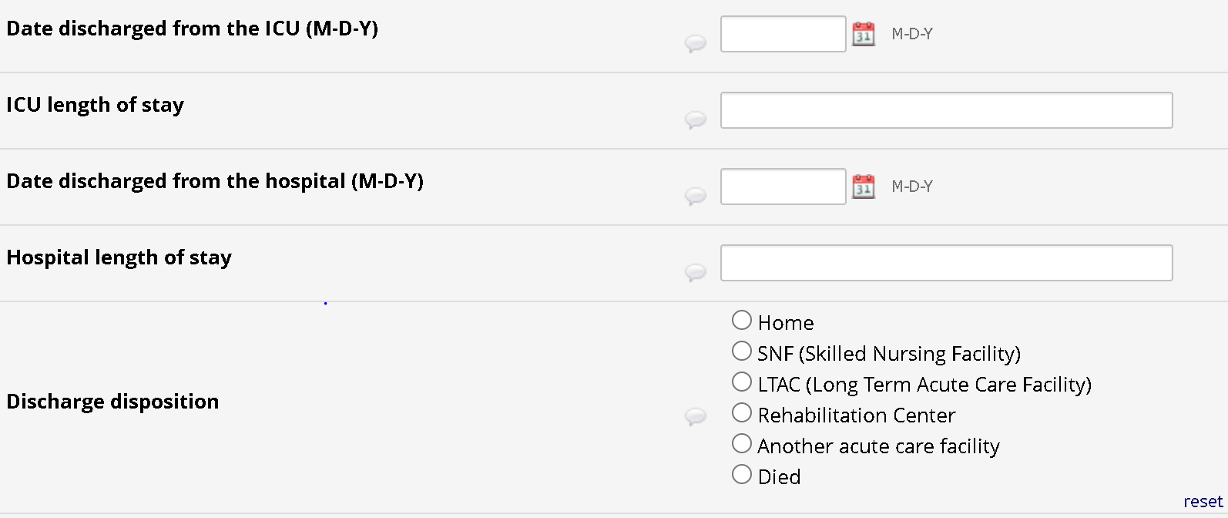

Item: Date discharged from the ICU: Enter the date the patient was discharged from the ICU. If the patient was never in the ICU, leave the time blank.

Item: Length of stay in the ICU.For patients requiring ICU care, this continuous variable is recorded in days. It is calculated by subtracting date of ICU admission from the date of ICU discharge. If the patient was never in the ICU, leave the item blank.

Item: Date discharged from the hospital: Enter the date the patient was discharged from the hospital.

Item: Length of hospital stay.This continuous variable is recorded in days. It is calculated by subtracting date of hospital admission from the date of hospital discharge.

Item: Discharge disposition: This categorical variable describes the outcome of patient discharge, whether to home, a skilled nursing facility (SNF), long-term acute care hospital (LTAC), rehabilitation facility, transfer to another acute care hospital, or patient death.



Item: Post procedural complications.This categorical variable is defined as the presence of procedure-related complications within 30 days after the procedure. If no post-procedural complications are identified, select ‘No’. If ‘No’ is selected, then no additional information is required for this item. Select ‘Yes’ if a post-procedural complication was identified. If ‘Yes’ is selected, an additional item will appear (see below).

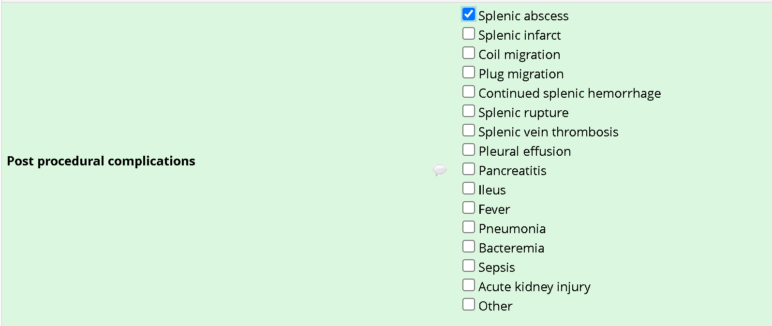

The most common post-procedural complications are listed. Select all that apply. If ‘Other’ is selected, a box will appear that will allow you to free text a complication that is not listed here.

For each complication, provide the date the complication was identified, its grade (A-F) according to SIR criteria, and describe how the complication was managed (e.g., splenic abscess managed with percutaneous drain; OR splenic infarct not requiring treatment; OR pleural effusion requiring chest tube) (see below).

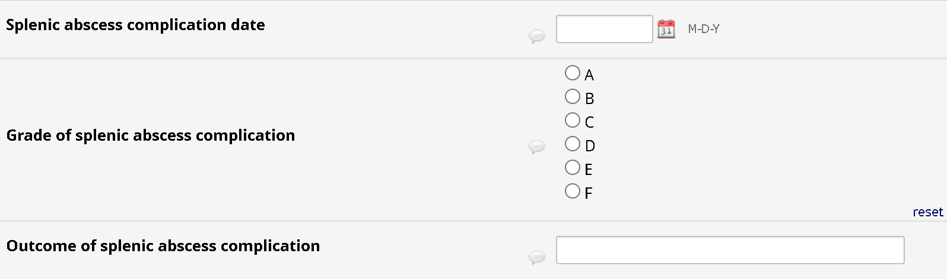



Item: Did the patient undergo splenectomy for any reason? This categorical variable is defined as whether the patient underwent a splenectomy for any reason within 30 days of splenic artery embolization. Record ‘Yes’ if the patient underwent splenectomy for any reason within 30 days of splenic artery embolization or ‘No’ if the patient did not undergo splenectomy for any reason within 30 days of splenic artery embolization. If ‘No’ is selected, no more information is needed for this item. If ‘Yes’ is selected, record the date of splenectomy and free text the reason for splenectomy (below).

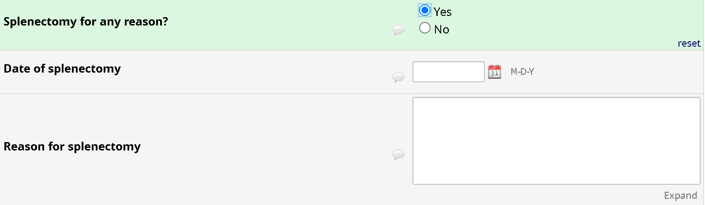

When you are done with the section, make sure to mark the form ‘Complete’ (red circle, below) by clicking on the drop down arrow next to the ‘Incomplete/Complete’ box. At that point, you can click on ‘Save & Exit Form’ if you are done entering data on the subject for the time being or click on ‘Save & Go To Next Form’ to continue entering data on the subject.



**Section 12 – Safety monitoring**

**12.1 Error checking in CRF**

Each item on the web forms has validity checks performed to ensure that the data entered are accurate and that items are not skipped during entry by mistake. Depending on the question, any item found that does not meet the respective edit criteria will result in an error message when the user tries to save the data.

All site investigators will be trained to follow regulatory procedures when making any changes in the paper forms or source documentation (no erasures, cross through error, write in correction, date, and initial). Once a follow-up about any errors has been done by CIS staff and the error has been corrected or certified as accurate, the status will change to “complete with errors.”

Once a record has been saved by the site or CIS as complete, they will no longer be allowed to make changes to the records. At the end of the trial after all possible corrections are made, the database will be locked and further changes will not be made.

**12.2 Risks to subject**

This trial will randomize 250 subjects who have sustained a high-grade, traumatic splenic injury. Based on past data, the majority of traumatic injuries occur in male subjects 45 years of age and younger. The majority of this population will have no significant pre-existing medical history. Children estimated to be less than 15 years of age, women who are known to be pregnant, and prisoners will be excluded from this trial. As all devices used in this trial are approved by the FDA, we anticipate no new risks to those seriously injured trauma patients. All patients will receive standard of care therapy for their injuries.

**12.3 Potential risks**

Eligible subjects for this trial will have been identified as requiring splenic embolization due to their traumatic injury. There is a potential risk that treatment may be delayed due to the randomization process. To monitor the potential risk, the clinical research staff will document relevant times including: time of ED admission, time of referral to interventional radiology, time of randomization, time of commencement of procedure. This is standard practice at all Level I trauma centers. If a delay or risk is identified, appropriate information/data will be sent to the medical monitor to decide if further action needs to be taken. Severely injured subjects who require splenic embolization will frequently incur complications such as death, multi-organ failure (MOF), respiratory complications, and infections. There is no expectation of increased harm in either groups. Subjects will have no additional costs for participating in the study.

**12.4 Protection against risks**

Consent to participate will be obtained as described. Subjects will be given the opportunity to continue or withdraw from the study at any point.

**12.5 Vulnerable populations**

This trial may include subjects aged 15 and older. Subjects aged 15 years and older are considered as adult trauma subjects in most trauma centers in the United States. Fifteen, sixteen and seventeen year olds are able to drive in most states and are at high risk for motor vehicle accidents resulting in splenic injuries. Excluding this age group would decrease our efforts to randomize 250 subjects in a two year period of time. Children below the age of 15 or 50kg body weight will be excluded from this trial. Pregnant women will also be excluded from the ELSA 2 trial, in whom the risks and benefits of embolization (with attendant ionizing radiation exposure) compared with splenectomy may differ. Prisoners admitted to the ED from a correctional facility will be excluded from enrollment. It is possible that subjects may be enrolled into the ELSA 2 trial who are under police observation as suspects. These subjects will remain in the study until discharge or incarcerated.

**12.6 Responsibility of the Medical Monitor**

An independent medical monitor will review all adverse events and provide an unbiased written report of the events. The medical monitor must comment on the outcomes of the event or problem and in case of an serious adverse event, comment on the relationship to participation in the trial.

If an event is considered unexpected and is either suspected or probably due to treatment, this event will be promptly reported to the medical monitor, who must indicate whether he/she concurs with the details of the report provided by the principal investigator.

Dr. Jeff Kerby (Director, Division of Acute Care Surgery) is the independent medical monitor for this study. He has committed to comply with the following statements:

The monitor:

1. Is independent of the research team.
2. Possesses sufficient educational and professional experience to serve as a subject advocate.
3. Will promptly report discrepancies or problems to the IRB.

The medical monitor must also indicate whether he/she concurs with the details of the report provided by the principal investigator. Reports for serious adverse events determined by either the investigator or medical monitor to be possibly or definitely related to participation must be promptly reported to the IRB.

**12.7 Adverse events**

Adverse events are non-device-related medical occurrences, further classified as serious adverse events (SAE) or non-serious adverse events (AE).

**12.7.1 Non-serious adverse events**

Events classified as ‘non-serious’ by the criteria listed in 12.7.2 need to be logged on the CRF, and the study team at the Center for Injury Science needs to be notified by sending a copy of the completed CRF to ELSA2@uabmc.edu within 10 working days. The site Primary Investigator will also need to report the event to the site IRB within 10 working days.

**12.7.2 Serious adverse events**

Serious adverse events are untoward medical occurrences in a subject that are not related to the investigational device, comparator, or trial procedures, but that meet the criteria of “serious.” A serious adverse event is one that:

1. Led to a death
2. Led to a serious deterioration in the health of the subject that:
   1. Resulted in a life-threatening illness or injury, or
   2. Resulted in a permanent impairment of a body structure or a body function, or
   3. Required in-patient hospitalization or prolongation of existing hospitalization, or
   4. Resulted in medical or surgical intervention to prevent life threatening illness or injury or permanent impairment to a body structure or a body function
   5. Led to fetal distress, fetal death, or a congenital abnormality or birth defect.

A planned hospitalization for a pre-existing condition or a condition required by the protocol, without serious deterioration in health, is not considered serious.

**12.8 Reporting period**

The reporting period includes any adverse events which occurred between randomization and patient exit from the study.

**12.9 Reporting procedure**

All members of the patient management teams will be instructed as to the possible adverse events prior to the start of the trial and will be given contact information to report any suspected adverse event to the site investigators.

Any possible untoward medical occurrence is identified will be evaluated and classified by the site PI, as follows:

1. Seriousness: Serious (meeting the criteria listed above) or not
2. Anticipated: Anticipated (matching the conditions shown in the list below) or unanticipated

**12.10 AEs form**

Adverse events that are not deemed serious will be recorded with the information required by the form below.

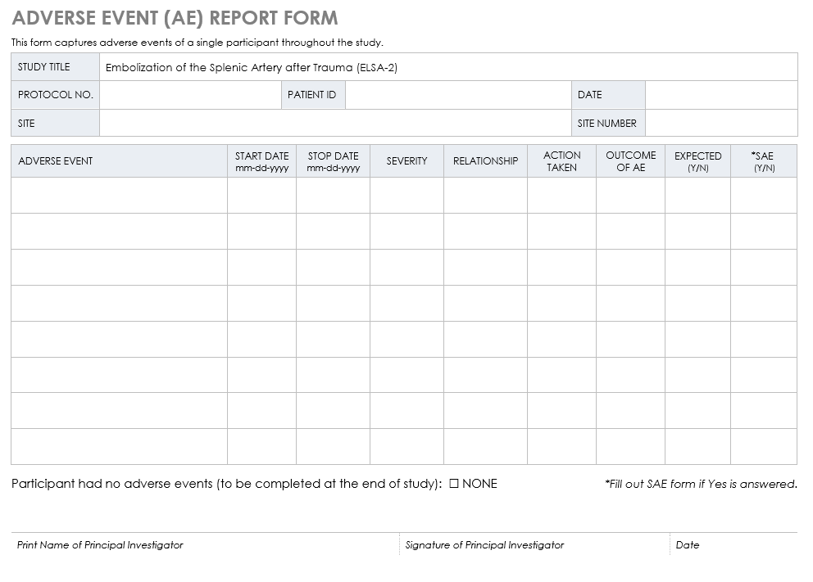

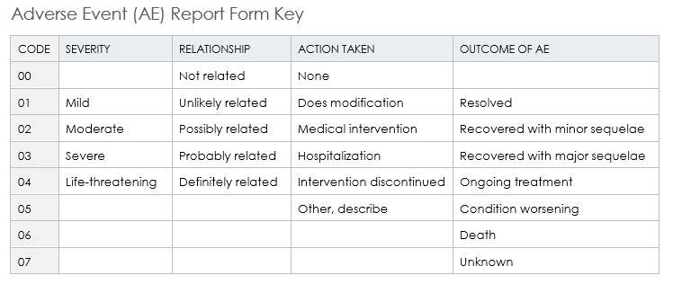

**12.11 SAEs form**

Anticipated serious adverse events will be reported by the site Primary Investigator to the site IRB, and will also be emailed to the ELSA trial office within 72 hours. These will be forwarded to the independent medical monitor. An independent medical monitor will review all adverse events and provide an unbiased written report of the events. The medical monitor must comment on the outcomes of the event or problem and in case of a serious adverse event, comment on the relationship to participation in the trial. If deemed necessary by the independent medical monitor, all sites will be notified by the trial office.

**SEVERE ADVERSE EVENT (SAE) REPORT FORM**

|  |  |  |  |
| --- | --- | --- | --- |
| STUDY TITLE | Embolization of the Splenic Artery after Trauma (ELSA-2) | | |
| PROTOCOL NO. |  | SITE NO. |  |
| SITE |  | | |
| PATIENT ID |  | DATE OF REPORT | dd-mm-yyyy |

|  |  |  |  |  |  |  |  |  |  |  |  |  |
| --- | --- | --- | --- | --- | --- | --- | --- | --- | --- | --- | --- | --- |
| 1. | SAE Date of Onset: | | | dd-mm-yyyy | | | | | | | | |
| 2. | SAE Date Stopped: | | | dd-mm-yyyy | | | | | | | | |
| 3. | Location of SAE: | | |  | | | | | | | | |
| 4. | Was this an unexpected adverse event? | | | | | | | Yes  No | | | | |
| 5. | Brief description of participants (do not include personal identifiers): | | Gender | | | | | Male  Female  Other, identify | | | | |
| Age | | | | |  | | | | |
| Diagnosis  for study participation | | | | |  | | | | |
| 6. | Brief description of the nature of the SAE:  *attach description,*  *if applicable* | |  | | | | | | | | | |
| 7. | Category  of SAE: | | Date of Death: | | | | dd-mm-yyyy | | | | | |
| Life threatening | | | | Congenital anomaly, birth defects | | | | | |
| Life threatening | | | | Required intervention to prevent impairment (permanent) | | | | | |
| Hospitalization | | | | Disability | | | | | |
| Other: | | |  | | | | | | |
| 8. | Describe intervention type: |  | | | | | | | | | | |
| 9. | Relationship of event to intervention: | | | | | | | | | Unrelated | Possible | Definite |
| 10. | Was the study intervention discontinued due to the event? | | | | | | | | | Yes  No | | |
| 11. | What steps were taken to treat the SAE? |  | | | | | | | | | | |
| 12. | List relevant tests, lab data, history, and pre-existing medical conditions: |  | | | | | | | | | | |
| 13. | Report type: | Initial | | | Follow-up | | | | Final | | | |

|  |  |
| --- | --- |
|  | |
| *Print Name of Principal Investigator* | |
|  |  |
| *Signature of Principal Investigator* | *Date* |

**12.12 USAEs reporting procedure**

Unanticipated serious adverse events will be reported by the site Primary Investigator to the site IRB and emailed to the ELSA trial office within 10 days, with notification of the trial Primary Investigators by telephone within 72 hours. Upon receipt of an unanticipated serious adverse event, the trial office will notify the independent medical monitor. An independent medical monitor will review all adverse events and provide an unbiased written report of the events. The medical monitor must comment on the outcomes of the event or problem and in case of an serious adverse event, comment on the relationship to participation in the trial. If deemed necessary by the independent medical monitor, all sites will be notified by the trial office.