UAB Civil, Construction, and Environmental Engineering (CCEE)
GRADUATE PROGRAM
Doctoral Proposal Defense Evaluation Form

DATE OF Proposal:

STUDENT:

EVALUATOR: Faculty
Student
Industry
Other

Excellent |  | Good |  | Poor
5 | 4 | 3 | 2 | 1

OUTCOME AREA
Knowledge of Engineering and Sciences
Knowledge of Literature in research area
Effective written communication skills
Effective oral communication skills
Ability to evaluate data critically
Ability to design and execute independent research plan
Evidence of creative use of scientific knowledge

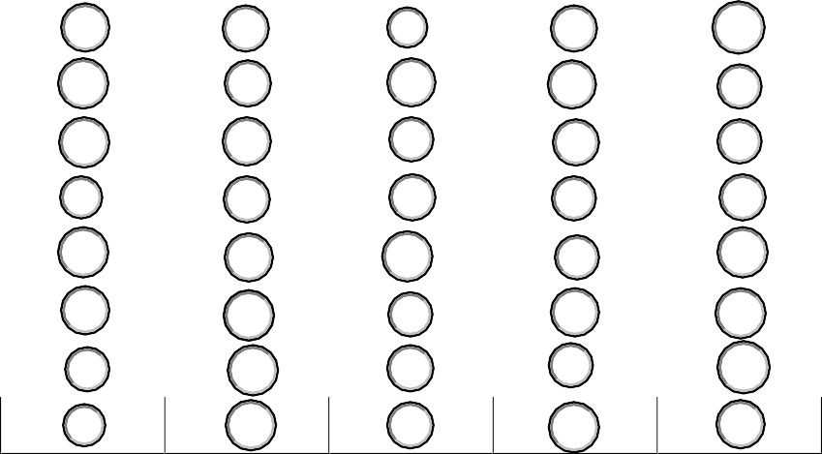
Total Score:

Please provide explanation for rating and suggestions for improvement:

