

SEHS Directions for Canvas Set-Up & Teaching - Recommended Best Practices
This checklist outlines best practices for set-up, organization and teaching your course in Canvas. Contact Dr Laura Forbes, SEHS Canvas Coordinator with questions ltalbott@uab.edu
*Note: The words module or week can be used interchangeably. Some of us teach by week and separate chapters and others teach by content and will spend several weeks on one module. Apply as it pertains to the structure of your course.

BEFORE THE TERM STARTS – CANVAS ACCESS

BlazerNet and Canvas (New Faculty)
- Have you activated your Blazer ID and signed up for a university email address? You will not be able to access BlazerNet and Canvas until this step has been completed.
- Are you able to log into BlazerNet and Canvas? Attempt to log in to ensure your credentials are working.

Obtaining Course Content (New Faculty)
- Once you have entered Canvas, check to see if the link to your assigned course appears.
- Does your course have content?
  - If not, complete a Course Copy Request.
  - Do you need to have courses cross-listed? If so, submit a Course Cross-Listing Request.
- YOU HAVE VARIOUS OPTIONS FOR COURSE SHELLS BASED ON WHAT YOU ARE TEACHING (online, T-Th on-ground, etc). Add the appropriate Course Template to your Canvas shell (see Picture 1). If you import the SEHS Course Template found in Canvas Commons, the homepage will look similar to Picture 2.
Picture 1
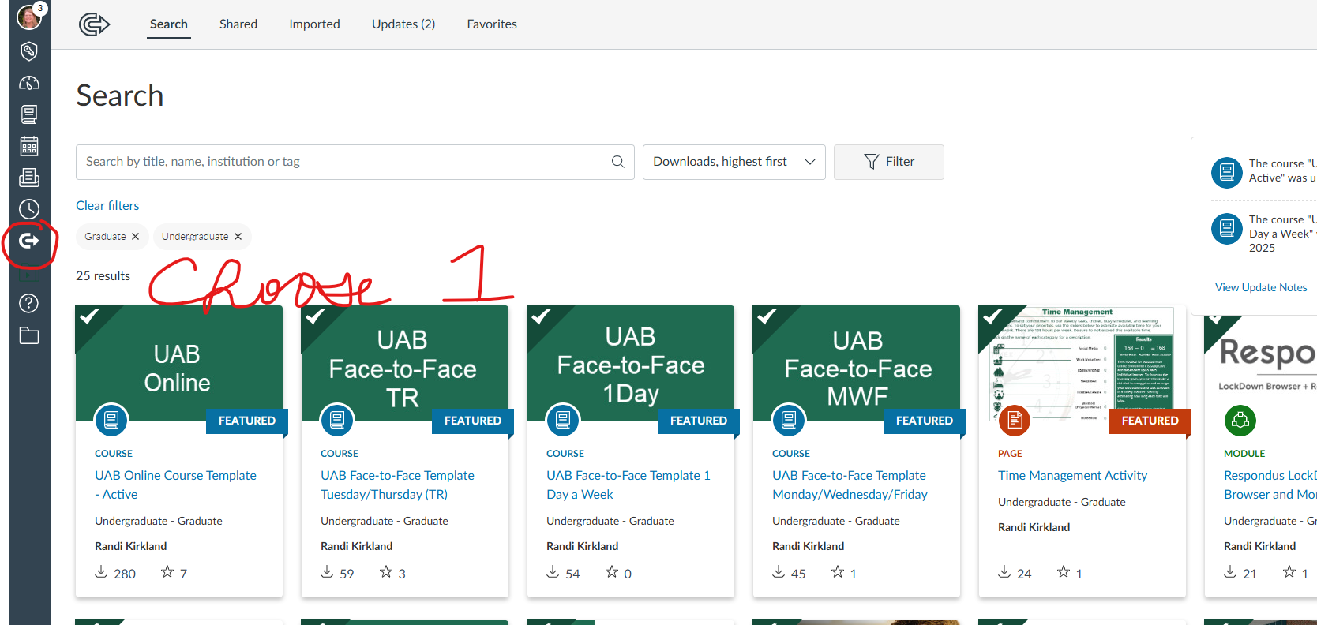

Picture 2
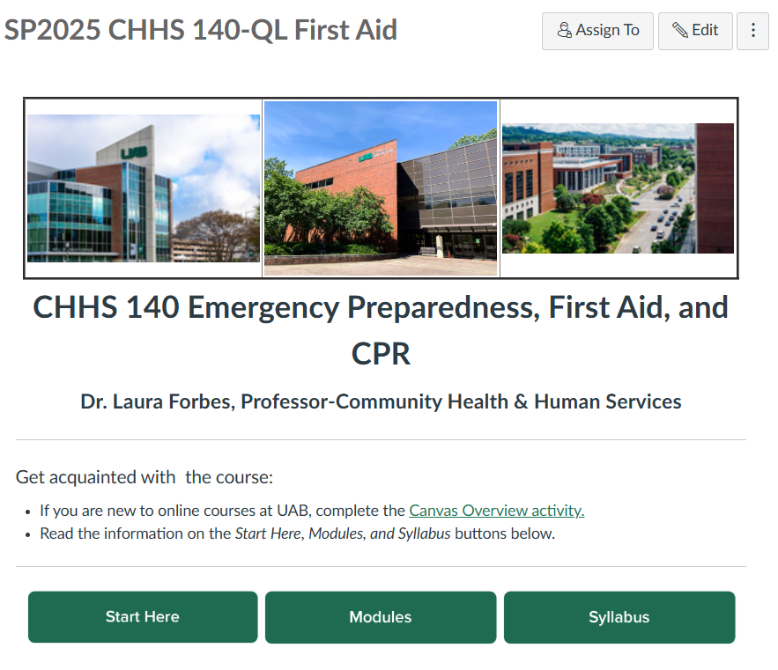

BEFORE THE TERM STARTS – CANVAS SETUP

Go through each highlighted section to update with your information in Canvas.

Start Here (Getting Started)
The template has a Start Here button that takes students to the Start Here module in Modules. Encourage your student to read this the first day of class for important information.
The following pages appear in the ‘Start Here’ module. You will need to go in and update this information.
- Course Overview, Course Format, Learning Objectives:
- Insert the course description from the UAB Course Catalog.
- Explain any required synchronous meeting times, dates and technology (Zoom or Microsoft Teams) to be used. Be sure your course times and meetings align with what was posted prior to the start of the term.
- List course learning objectives to be specific, measurable statements that define what a student should be able to do after completing your course.
- Learning objectives (desired outcomes) are intended to guide instructional design, ensure alignment between chapter/weekly objectives and link to the selected learning activities.
- Instructor Introduction, Office Hours, Zoom Instructions:
  - Update the information for you and your circumstances.
  - In addition to the text, consider best practices and record the paragraph with transcription, better yet show your ‘digital personality’ and connect with students via a short video (3 minutes or less) introducing yourself.
  - It is appropriate to include some personal information to help you build rapport. Let them know you outside of your credentials. Use Kaltura to record/upload the video and embed on this page.
  - Provide students with your virtual office hours and means of alternate contact should there be an emergency.
- If holding standing office hours or wishing to meet students via Zoom, consider inserting your personal link and allow them to request a time or date by appointment.
- Student introduction in the virtual café (This is appropriate for an online course). This is for students to introduce themselves to you and their classmates. It is a great way to connect and engage with students and help them feel welcome. The SEHS template contains a set of pre-populated questions that you can edit based on your needs (this is worth 0 points). As students submit an introduction, go in and respond back to them with a welcome and friendly comment about their post.
- Netiquette (Tutorial):
  - Students learn appropriate internet and e-mail etiquette for the academic environment.
- Student Syllabi Agreement:
  - Edit this page to fit course due dates and weekly/module structure. Students are acknowledging that they are aware of your policies and have read the syllabus.
- What’s Next?:
  - This page explains how the course is set up and what the student should do next to get started on the course content (Modify for your needs)
SEHS Template for Start Here:
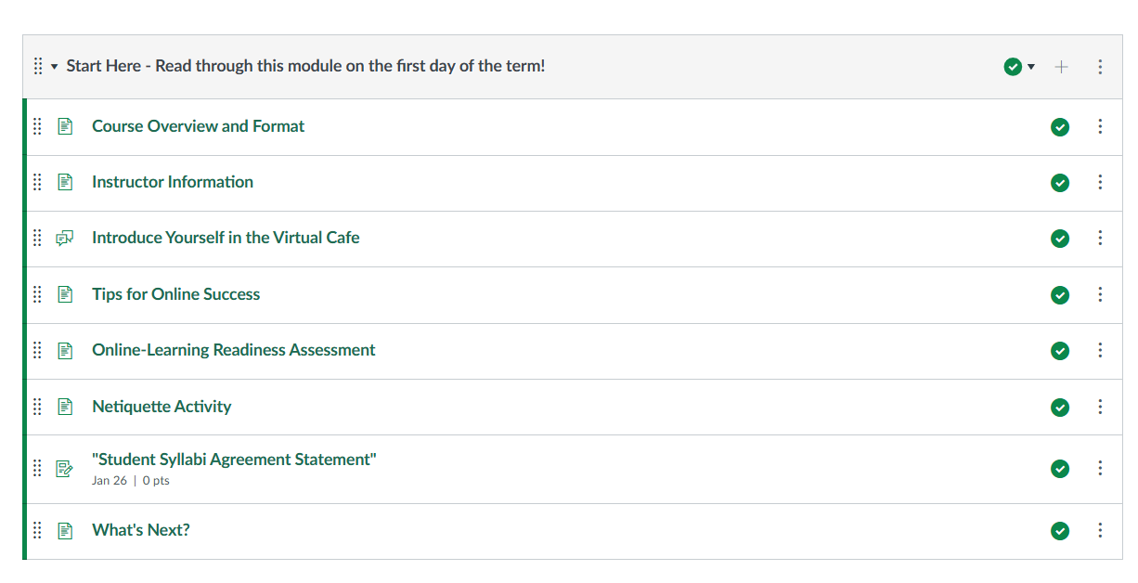

Each Week/Module Components
Best practices indicate that each week/module should contain the following elements.
WELCOME
- Welcome to Week/Module X: This section provides an overview of what is going to happen in three parts. Give the week/module an interesting title.
  - Overview: Share with students what they are to learn for the week and how it ties to the previous content.
  - Week/Module Learning Objectives: Provide a list of week/module objectives that ties to the objectives met by assignments, quizzes, or discussions.
  - Required Activities: Provide students with a list of tasks to complete which may include readings, lectures, assignments, etc. This serves as a checklist of what they need to do to complete the module.

CONTENT
- Week/Module X Instructional Materials:
  - This is where you will store chapter readings, PowerPoint slides, lecture videos/notes, websites you want students to visit and read, other assigned readings.
- BASIC – At a minimum, post lecture PowerPoint slides related to textbook reading and other pertinent content for the week.
- BEST PRACTICES – Lecture Video: Include an instructor-created lecture to explain concepts, provide examples, and expand on readings. Research suggests that uploading publisher created slides without instructor created narration are not as effective. In the example below, the textbook came with publisher slides that were posted as flat content, some learners like to listen to the narrated lecture and take notes on printed slides, others like to read the captioning while exercising, so more mediums are better to ensure that learner types are considered.
- Keep videos to 10 minutes or less, even if you need multiple videos per module. This addresses issues with internet speeds/bandwidth and attention span.
- Lecture videos created in Kaltura Capture automatically provides closed captioning.
- If new to using Kaltura Capture downloading the app to your desktop will be required.
- Before recording, be sure that the lecture material is present, and you can opt to show yourself to the students.
- Once the lecture materials have been created the file will appear in ‘My Media’ and can be embedded into a Page.
- Review course lectures and videos to ensure closed captions are available for students with hearing impairments. Contact Dr Laura Forbes for assistance.

REQUIRED ACTIVITIES
- Post all assignments, quizzes, projects, or discussions that link to the week/module learning objectives. For consistency, include the work to be completed under this header.
  - If students need to read something other than the text to complete an assignment, link the article in the assignment/quiz/discussion instructions so that have that article immediately before completing the activity. If it is posted below the activity, they might not see it until after they complete the activity.
- Week/Module X Checklist: This is easy to create by copying and pasting the week/module tasks you have already written in the Welcome section and making the list into check box bullets that students can mark off like a to do list. Put this checklist into a MS Word document and link it for easy printing.

OPTIONAL LEARNING
- Post content that enhances learning the topic – (see one example below). There are many different options (TED Talks, current events, self-assessments, research articles, online certifications)
- The intent is to post content that encourages the student to take a deeper dive into the topic.
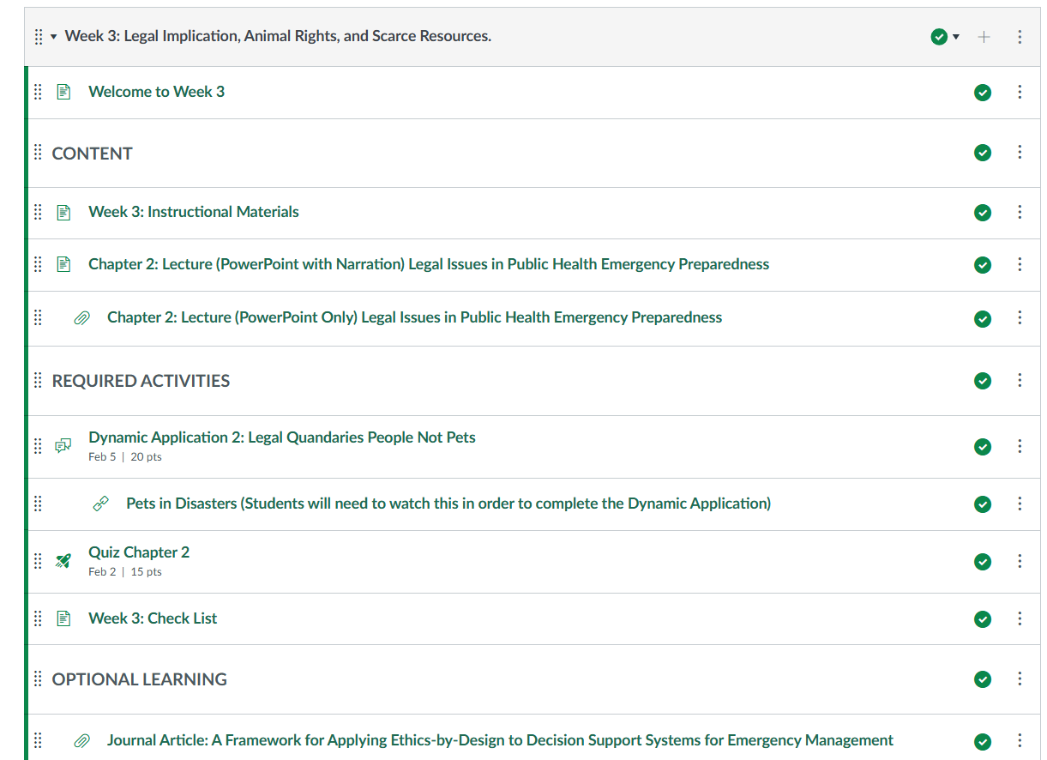

Syllabus and Schedule
- UAB/SEHS has adopted the Simple Syllabus, Follow the link for instructions.
- Update the syllabus for your course.
  - Instructor contact information.
  - Dates (Consult the Academic Calendar)
- Edit dates in your course assignments, discussion, quizzes, etc. in Canvas.
- You should NOT remove key assessments or standards. If there are questions, contact Dr Sheek lsheek@uab.edu

Review Content and Technology
- Review content on all pages in the course and update as needed.
  - Edit or remove dates as needed.
  - Edit instructor contact information or any content that references the previous instructor.
  - Read each page of the course to ensure that content of a previous instructor is removed.
  - As you review the content, determine which learning technologies (in addition to Canvas) are used in the course. Poll Everywhere, GoReact, and Respondus LockDown browser are just a few of the 30+ technologies available at UAB. Ensure that the technology is working properly. Each technology has a support page of its own that can be the first place of assistance for you and your students.
  - If you update text, keep accessibility in mind. Some students use a screen reader or other assistive technology. Keep the font size and color contrast in Canvas and on your other documents in mind. Contact Dr Forbes for assistance if needed.

UDL and Accessibility
- As you communicate with students, author weekly course announcements, and make minimal changes to content, avoid slang terms, colloquialisms, and brand names that would not be widely known by students from different countries or different areas of the country.
- At the beginning of the term or at any point in the term, you may receive an email from the UAB Disability Support Services (DSS) notifying you that a student has been granted accommodations. These communications are important and should not be ignored.

Gradebook
- Check the grade scheme. Make sure this is set up correctly and matches what is on the syllabus.
- Review the Assignments page to ensure the final grade will be calculated correctly and matches the grading scheme and policy on the syllabus.
- Check the Grade Posting Policy settings in the gradebook.

Groups
- If you use Canvas Groups or CATME, set up groups accordingly.
- If assigning projects/papers to be submitted as a group, make sure those specific assignments are set to be group assignments.

Check Links
- Use the Canvas Link Validator to check for broken links in your course and fix them.

ONCE THE COURSE IS SETUP AND READY TO GO, MAKE CONTENT AVAILABLE TO STUDENTS
- Publish module content.
- Publish the course.

NEXT: RECOMMENDED BEST TEACHING PRACTICES (especially for 100% online courses)

Email Students Before Class Starts
- Communicate with your students a week prior to the start date via email using BlazerNet. Send an introductory email, share the course syllabus, your virtual office hours, the textbook being used, and your preferred method of contact. Give them a brief overview of the class.

Announcements
- Welcome Announcement:
  - This initial announcement introduces students to the course and instructor. Schedule it to post the first day of class. Consider using a video, your picture, or a fun fact!
- Weekly Announcements:
  - This is an opportunity to connect concepts or content from one week to the next, integrate current events. Announcements are meant to engage the student and may be posted in text or video format.
  - To eliminate confusion, delete any announcements copied over from the previous term if you do not plan to use them this term.
  - Schedule (postdate) other announcements to remind students throughout the course as needed.

DURING THE SEMESTER

Communication During the Semester
- Respond to all student e-mails through your UAB email within in 24-hours.
- Require that all students communicate with you from their UAB email account.
- Refresh your understanding of the Federal Education Rights and Privacy Act.

Effective Feedback
- Carefully consider your schedule and plan out sufficient time to grade assignments.
- The use of clickable rubrics are best practice and will automatically calculate the score in the gradebook. If needed, ask Dr Forbes for assistance.
- Student grade feedback for each assignment/task should be substantive in that it is important, meaningful, or well-supported rather than cursory (e.g., “Good job”).
- Grades should be recorded in Canvas within 7 days of student submission to ensure timeliness.
- If it did not happen in Canvas, it did not happen. Grading work outside of Canvas/via email is discouraged. Students should submit assignments in Canvas so there is a record of submission and substantial feedback. This protects the instructor and student if there is a grade dispute later.

END OF SEMESTER

Submitting Grades
- Check your gradebook for anything that has not been graded. Students may submit at the last minute for grade consideration. Be consistent with enforcing your ‘late submission’ policies.
- The point or weight scheme set at the beginning of the term should be in place. If there are icons prohibiting totals, please reach out to Dr Forbes.
- After grading all assignments/discussions/papers, review the gradebook and submit your final grades in BlazerNet.
- Review the grade submission process using Canvas to talk to Banner if needed.
- During the grading window, BlazerNet will show the Canvas Grades Icon (second from right). Click on this and follow on-screen prompts.
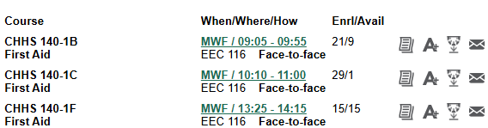
- With regards to the “A+” icon, click this to enter Incomplete semester grades.
- Also use the “A+” icon if you entered a grade of “F” so that you can enter the date of last attendance if student completed the course or last date of course engagement if the student ceased participation at any time.

